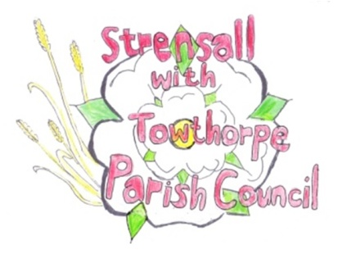
Strensall with Towthorpe Parish Council
The Village Hall, Northfields, Strensall, YORK, YO32 5XW.
Tel: 01904 491569
Email: clerk-strensallpc@btconnect.com

Chairman Councillor Keith Marquis

MINUTES of the meeting of The Parish Council Planning Committee held on Tuesday 11th October 2016 at 6.30pm in the Village Hall, Strensall

Present:

Cllr Chambers (Chair) Cllrs Marquis, Plant, Bolton, Fisher, Maher, Mattinson and Harvey-Walker

Apologies:

Were received from Cllr Chapman who is on holiday

Declarations of Interest

None Declared

Minutes

The minutes of the previous meeting had been circulated and it was resolved that these were signed without alteration as a true record of the meeting Resolution P111016/01

Ongoing Issues

Cllr Marquis drew the attention of the committee to the YLCA White Rose Update and the fact that it was now necessary to apply for permission from City Council to display and project electronically to members of the public a planning application and associated plans. The Clerk was asked to contact Michael Slater and make the request. Resolution P111016/02

Planning Applications

(a) 16/02220/FUL – Proposed single storey rear extension Duncombe Drive
The Parish Council has no objections

Planning Decisions

(a) AOD/16/00279 - revocation of condition 19 of approval 12/03149/FLM on the site of the old Tannery works – APPROVED WITH CONDITIONS

(b) 16/01842/FUL – Single storey rear extension To 3 Wood Close – APPROVED

(c) 16/01125/FUL – Single storey side extension to 1 Moorland Garth –APPROVED

The date of the next meeting is Tuesday 25th October 2016 at 6.30pm

Signed………………………………………………Chairman Dated 25th October 2016

