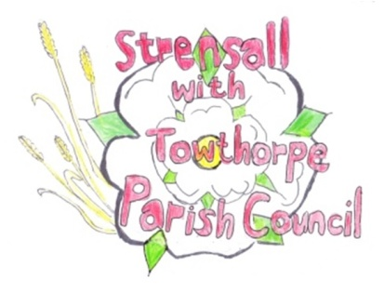
Strensall with Towthorpe Parish Council
The Village Hall, Northfields, Strensall, YORK, YO32 5XW.
Tel: 01904 491569
Email: clerk-strensallpc@btconnect.com

Chairman Councillor Keith Marquis

MINUTES OF THE MEETING OF THE PARISH COUNCIL PLANNING COMMITTEE
Held on Tuesday 12th April 2016 at 6.15pm at the Village Hall, Strensall

PRESENT

Cllr Chapman (Chair) Cllrs Marquis, Bolton, Fisher, Chambers, Maher, Mattinson and Harvey-Walker.

1. AP0LOGIES

Were received from Cllr Plant

2. DECLARATIONS OF INTEREST

None

3. MINUTES

The minutes of the previous meeting as circulated were approved and then signed as a true record Resolution P120416/01

4. ONGOING ISSUES

(a) Moorlands Nursing Home - the Clerk reported that the Nursing home had been given 2 weeks to remove the sign erected on land belonging to City of York Council
(b) 4 Hawthorn Mews – a new application had been received for the removal of a tree which it was felt to be a possible danger to the public and it was agreed to discuss and respond to this application immediately

5. PLANNING APPLICATIONS

(a)) 1600612/FUL – proposed single storey rear extension to 9 Church Lane
The Parish Council has no objection

(b) 16/00649/LHE– proposed rear extension to 11 Church Lane
The Parish Council, although would comment that this application requires full planning application as in conservation area 23 but would have no objection to the proposal which would work in tandem with No.9

(c) 16/00654/FUL proposed single storey rear extension to 5 Duncombe Drive
The Parish Council has no objection

(d) 16/00434/FUL – proposed single storey front extension and canopy to the side of Army Welfare Services, Border Road
The Parish Council has no objection to the actual build but would question the proximity of the existing foul water pumping station to the proposed extension
(e) 16/00702/FUL –proposed conversion of garage into home office, single storey rear and side extensions and raising of garage roof at 6 Westpit Lane
The Parish Council has no objections

(f) 16/00816/TCA – proposed felling of a fir tree at 4 Hawthorn Mews –
The Parish Council agree there is a potential danger to users of the play area at The Ship and support the application

6. PLANNING DECISIONS: -

(a) 16/00196/FUL - Dormer to rear of 119 The Village-APPROVED
(b) 16/00303/FUL – single storey rear extension to 60A Moor Lane- APPROVED
(c) 16/00228/FUL –retention of shower and toilet block a Country Park – REFUSED

7. To confirm date and time of next meeting as Tuesday 26th April 2016 at 6.30pm followed by the Neighbourhood Plan meeting

Signed……………………………………………………………….... Chairman

26th April 2016

