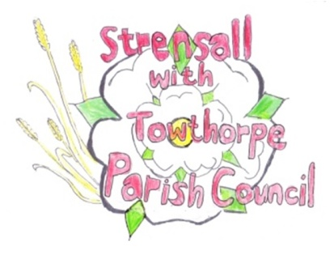
Strensall with Towthorpe Parish Council
The Village Hall, Northfields, Strensall, YORK, YO32 5XW.
Tel: 01904 491569
Email: clerk-strensallpc@btconnect.com

Chairman Councillor Keith Marquis

MINUTES OF THE MEETING OF THE PARISH COUNCIL PLANNING COMMITTEE
Held on Tuesday 26th April 2016 at 6.30pm at the Village Hall, Strensall

PRESENT

Cllr Chapman (Chair) Cllrs Marquis, Bolton, Fisher, Plant, Maher, Mattinson and Harvey-Walker.

1. AP0LOGIES

Were received from Cllr Chambers

2. DECLARATIONS OF INTEREST

None

3. MINUTES

The minutes of the previous meeting as circulated were approved and then signed as a true record Resolution P260416/01

4. ONGOING ISSUES

A response to the business questionnaire had been received from Pullman Bus Company requesting dialogues with the Parish Council regarding problems with their site off Pottery Lane. It was agreed that this was not within the Parish Council remit and should be passed to City of York Council Planning Officer who had dealt with the recently refused planning application 15/00711/FUL.

5. PLANNING APPLICATIONS

(a) 16/00793/FUL – proposed single storey side extension at 7 Kirklands
The Parish Council does not object but expresses the concern that there is no provision for a cycle and bin store following the demolition of the garage

(b) 16/00819/TCA – proposed felling of 4 trees at 12 The Village
The Parish Council does not object but feels that the loss of any tree is regrettable and would wish to seek the advice of the Tree and Conservation officers

(c) 16/00836/TPO – proposed felling of an oak tree at 39 York Road
The Parish objects to the felling of a healthy and attractive oak tree and would seek the advice of the City of York Council Tree Officer as to any necessary maintenance. The application did not have a separate report from the tree surgeon re the condition of the oak apart from the applicant’s comment on the application form that the tree should be felled.

(d) 16/00729/FUL –proposed erection of a boundary wall at 2 The Village

The Parish Council does to object to the proposal but would wish the maximum height of the wall to be specified as the current height of the fence (1.8 metre) also the bricks should match the existing property.

(e) 16/00653/FUL –proposed conservatory at 3 Waltham Close
The Parish Council has no objections

6. PLANNING DECISIONS: -

(a) 16/00612/FUL – single storey rear extension to 9 Church Lane –APPROVED
(b) 16/00649/LHE – single storey rear extension to 11 Church Lane
REFUSED as requires full planning consent
(c) 16/00340/FUL –Extension to 5 Wood Close – APPROVED
(d) 16/00023.FUL – application for the removal of agricultural conditions of Petersons Nurseries - WITHDRAWN
(e) 15/02505/FUL – NOTICE OF APPEAL against the refusal of permission for variation on Plot 1 Manor Farm, Towthorpe

7. To confirm date and time of next meeting as Tuesday 10th May 2016 at 6.30pm

Signed……………………………………………………………….... Chairman

10th May 2016

