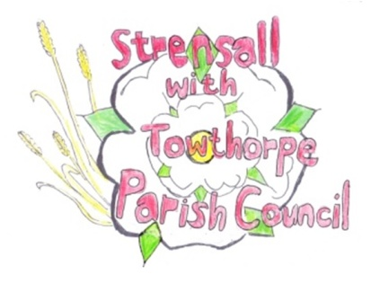
Strensall with Towthorpe Parish Council
The Village Hall, Northfields, Strensall, YORK, YO32 5XW.
Tel: 01904 491569
Email: clerk-strensallpc@btconnect.com

Chairman Councillor Keith Marquis

MINUTES OF THE MEETING OF THE PARISH COUNCIL PLANNING COMMITTEE
Held on Tuesday 8th March 2016 at 6.30pm at the Village Hall, Strensall

PRESENT

Cllr Chapman (Chair) Cllrs Marquis, Plant, Bolton, Fisher, Chambers, Maher, Mattinson and Harvey-Walker. 1 member of the public

1. AP0LOGIES

None received

2. DECLARATIONS OF INTEREST

None

3. MINUTES

An item in the minutes was questioned as inappropriate. This was discussed and agreed to be removed. The minutes as amended were then signed as a true record Resolution P080316/01

4. ONGOING ISSUES

(a) 12 The Village- the resident had required some roofing work done and the Chairman was concerned that, as the property is in the conservation area, this would require permission to remove the chimney pots. He had checked with the Planning Officer but this was not required.

(b) 521 Strensall Road- the caravan was still on site and the Chairman was asked to investigate the terms of the planning permission to see if a time limit had been set for its removal.

5. PLANNING APPLICATIONS

(a) 16/00265/FUL-proposed erection of dwelling house on land to the south west of Strensall Bridge, Sheriff Hutton Road
The Parish Council strongly object to this proposal
(i) the development site is in the flood plain and an updated flood risk assessment should be undertaken in the light of the recent flooding. See enclosed photographs showing extent of 26 Dec 2015 floods. The applicant states that the site is in Flood Zone 3 but the nearby Ship Inn is within Flood Zone 2. Clarification should be sought from the Environment Agency.
(ii) the design is inappropriate for a property within conservation area 23 and the views of the Conservation Officer must be obtained as the views from the North bank of the River Foss towards the Village will be adversely affected.
(iii) the land is in the green belt and the applicant has not provided evidence of special circumstances why the development should be allowed. It is also in the green river corridor.
(iv) It is understood that the disposal of sewage foul waste is to the private Hawthorn Mews pumping station subject to agreement of all involved residents from the adjacent properties
(v) As private foul pumping systems are to be adopted in October 2016 this aspect should be investigated with Yorkshire Water.
(vi) The Foss Internal Drainage Board must be also be consulted about the disposal of surface and possible treated foul water as indicated in this application.
(vii) It is understood a previous application to build on this land was made in c1999 and was either refused or withdrawn on advice of the Planning Officer. Information on the planning web site is not currently available and will have been archived.
(viii) The access road is in private ownership and such rights would need to be agreed. There is already major problems with access to the existing properties due to vehicles parked on the access road.
(ix) The application form describes the site’s former use as Builders Yard/Market Garden whereas the Contamination Assessment states that the site is Vacant Meadow Land. The latter is correct and the builder’s rubbish on the site was deposited when alterations were carried out to a nearby property.

(b) 16/00340/FUL – proposed porch to the front of 5 Wood Close
The Parish Council has no objections

(c) 16/00421/FUL – proposed single storey front extension to 9 Wood Close
The Parish Council has no objections

6. PLANNING DECISIONS: -

(a) 16/00035/FUL - erection of a general purpose store at The Vale of York Caravan Park – APPROVED

(b) 15/01895/FUL – attached dwelling to side of 42 Middlecroft Drive - APPROVED

(c) 15/02874/FUL –variation of condition 2 of permitted application at Manor Farm, Towthorpe - APPROVED

7. To confirm date and time of next meeting as Tuesday 22nd March 2016 at 6.30pm

Signed……………………………………………………………….... Chairman

22nd March 2016

