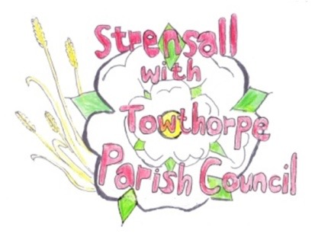
STRENSALL WITH TOWTHORPE PARISH COUNCIL
The Village Hall, Northfields, Strensall, York YO325XW
e-mail: strensalltowthorpePC@outlook.com
phone: 01904 491569

Chairman : Mr A H Fisher

MINUTES OF AN EX-ORDINARY MEETING HELD REMOTELY ON SATURDAY 01ST MAY 2021 AT 4.30PM
Councillors Present: Chris Chambers John Chapman Tony Fisher Duncan Hill Susan Nunn

In Attendance: Fiona Hill - Parish Clerk
Public Present: 0
- a) To receive apologies for absence given in advance of the meeting: Parish Councillors Cox, Donohoe and Ogilvy
b) To consider the approval of reasons given for absence:
Resolved – Approved (Unanimous)

- To receive any declarations of interest under the Parish Council Code of Conduct or
Members register of interests: None

- To discuss the costings for fitting a bench in the bus shelter at Northfields:
Resolved – A two person shelter bench would be purchased from www.shelterstore.co.uk at a cost of £199.00 plus VAT (Unanimous)
Resolved – The quote for £80.00, for fixing the bench, from M Duck was accepted (Unanimous)

- To discuss the costings for drainage and surfacing along the footpath between Moor Lane and Lords Moor Lane:
The Parish Clerk reported that two local businesses, known for their drainage works, had attended a site visit and been asked to quote. Only one quote had been received, as the other business had declined the opportunity.
Resolved – The quote for £19,694.00, for both drainage and surfacing works, from J Atkinson & Son was accepted (Unanimous)
Resolved – J Atkinson & Son would be asked to delay starting the work until September 2021, to avoid the bird nesting season (4 votes in favour, 1 vote against)

