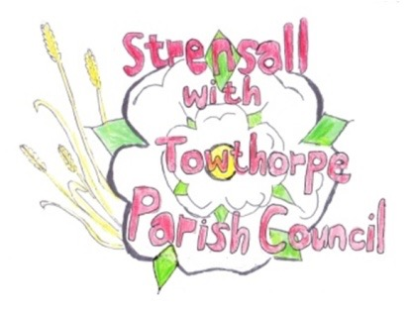
STRENSALL WITH TOWTHORPE PARISH COUNCIL

The Village Hall, Northfields, Strensall, York YO325XW
e-mail: strensalltowthorpePC@outlook.com
phone: 01904 491569
Chairman : Mr A H Fisher

MINUTES OF AN PARISH COUNCIL EXTRA-ORDINARY MEETING HELD IN THE VILLAGE HALL ON THURSDAY 28TH SEPTEMBER 2021 AT 7.30PM
Councillors Present: Andrew Bolton Chris Chambers (Chairman) John Chapman Tony Fisher* Ray Maher Lawrence Mattinson Susan Nunn
In Attendance: Fiona Hill - Parish Clerk
Paul Doughty *
Public Present: 1 – Chairman of Earswick Parish Council
* City of York Councillors
- a) To receive apologies for absence given in advance of the meeting: Parish Councillors Duncan Hill and Kevin Ogilvy
b) To consider the approval of reasons given for absence:
Resolved – Approved (Unanimous)

- To receive any declarations of interest under the Parish Council Code of Conduct or
Members register of interests: None

21/42 To discuss the design for the York Outer Ring Road dualling scheme, in particular, the design of the Earswick roundabout and prepare a response before the City of York Executive meeting to approve them on Thursday 30th September 2021:
Resolved – Strensall with Towthorpe Parish Council objects in the strongest terms to the proposed position of the cycle crossing. The pedestrian/cycle crossing should be moved at least 100 meters North of the junction of Strensall Rd and the A1237 for road safety reasons.
Resolved – Although not directly related to the scheme to dual the A1237, Strensall with Towthorpe Parish Council reiterates the desperate need for a safe cycle route between Strensall and Earswick, so would ask you to re-look at this as a matter of urgency.

