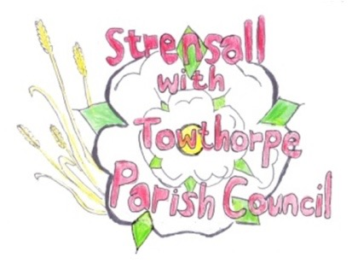
STRENSALL WITH TOWTHORPE PARISH COUNCIL
The Village Hall, Northfields, Strensall, York YO325XW

e-mail: strensalltowthorpePC@outlook.com phone: 01904 491569

MINUTES OF A PLANNING COMMITTEE MEETING HELD ON TUESDAY 09 MARCH 2021 AT 6.30PM

Councillors Present: Andrew Bolton Chris Chambers John Chapman Cllr Dr Cox Lawrence Mattinson

In Attendance: Fiona Hill - Parish Clerk
Public Present: 0

- a) To receive apologies for absence given in advance of the meeting: Parish Councillors Tony Fisher and Tony Gavin
b) To consider the approval of reasons given for absence:
Resolved – Approved (Unanimous)

- To receive any declarations of interest under the Parish Council Code of Conduct or
Members register of interests:
None

- To approve the minutes of the monthly Parish Council meeting of 23rd February 2021: Resolved – Approved (Unanimous)

- To discuss any ongoing issues and information received: - AOD/21/00050 – Discharge of conditions 11 12 and 19 - 19/02463/FULM @ Foss Upstream Storage Area Brecks Lane - AOD/21/00052 – Discharge of conditions 3,4,5,10 and 11 of 14/01447/FUL @ Hoxne Farm
House Sheriff Hutton Road
- AOD/21/00057 – Discharge of conditions 3 and 15 of 19/02463/FULM @ Foss Upstream
Storage Area Brecks Lane

The Chairman advised that Parish Councils were not formally consulted on this type of
application, but the information was included, so the committee were aware of the details.

- To consider and respond to consultations from City of York Council to the following
planning applications:
- 21/00155/FUL - Two storey side and rear extension, single storey side extension and rendering of building @ 12 Moorland Garth
Resolved – Objection (Unanimous), for the reasons as follows:
- The scale and mass is excessive
- The negative impact on the street scene of West End and York Road
- The site is adjacent to Conservation Area 23
The Parish Council would like to refer the officer to 20/01289FUL, 10 Tyneham Way and its reason for refusal We feel this application has a greater impact to the street scene /conservation area.
- 21/00343/FUL - Removal of conditions 7 and 8 of permitted application 12/03270/FUL to allow year round opening @ Country Park Pottery Lane
Resolved – Objection (Unanimous), as the reasons for the refusal decision, which were upheld at appeal, are still relevant to the site.
- 21/00283/FUL - Railings and gate to front @ York Cottage 47 The Village
Resolved – No Objections (Unanimous)
- 21/00392/FUL - Two storey side extension following demolition of car port/store @ 22 Ryecroft
Resolved – No Objections (Unanimous)
- 21/00437/TCA - Remove deadwood and 2no. stems from an Ash tree in the Conservation Area @ 129 The Village
Resolved – No Objections (Unanimous)

- To note planning decisions received: - 20/02509/CPD - Certificate of lawfulness for erection of a single storey extension to an
existing dwelling within former reservoir building – Granted
- 21/00057/TCA - Crown reduce Douglas fir tree by 30% - tree works in a Conservation Area @ 50 The Village – Consented

- To confirm date of next meeting as Tuesday 23rd March 2021 @ 6.30 p.m. Resolved – Agreed

