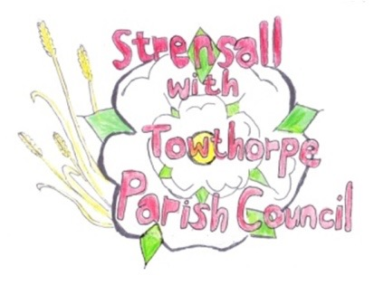
STRENSALL WITH TOWTHORPE PARISH COUNCIL
The Village Hall, Northfields, Strensall, York YO325XW

e-mail: strensalltowthorpePC@outlook.com phone: 01904 491569

MINUTES OF A PLANNING COMMITTEE MEETING HELD ON TUESDAY 10th AUGUST 2021 AT 6.30PM

Councillors Present: Andrew Bolton Chris Chambers John Chapman Tony Fisher

In Attendance: Fiona Hill - Parish Clerk
Public Present: 1 – Ray Maher

- a) To receive apologies for absence given in advance of the meeting:
Lawrence Mattinson
b) To consider the approval of reasons given for absence:
No reason given

- To receive any declarations of interest under the Parish Council Code of Conduct or
Members register of interests: Cllr Fisher – 21/01821/FUL – Applicant is a close friend

- To approve the minutes of the monthly Parish Council meeting of 27th July 2021: Resolved – Approved (Unanimous)

- To discuss any ongoing issues and information received: 21/01016/FUL – 40 Middlecroft Drive - Cllrs noted amendments

- To consider and respond to consultations from City of York Council to the following
planning applications:

- 21/01738/TPO - Crown clean and crown reduce Oak by 30% - protected by Tree Preservation Order no. 131/198915 @ 15 Oak Tree Way

Resolved – The Parish Council Objects to this application and would urge the City of York Council Tree Protection Officer to survey the site and recommend only necessary/appropriate works. In addition, the two previous refusals should be noted. (Unanimous)

- 21/01821/FUL - Single storey front extension after demolition of existing porch @ 36 Melcombe Avenue

Resolved – The Parish Council has No Objections to this application (Unanimous)

- 21/01588/FUL - Single storey rear extension (retrospective) @ 9 Shelley Drive

Resolved – The Parish Council has No Objections to the shed, but must point out that the recently purchased land is not garden, it is agricultural land (Unanimous)

- To note planning decisions received:

- 21/00937/FUL - Two storey side and rear extension @ 74 Middlecroft Drive – Approved

- 21/01270/FUL - Car park resurfacing and installation of tree protection system @ Robert Wilkinson Primary School - Approved

- 21/01035/FUL - Single storey rear extension, side and rear extensions to detached garage following demolition of garage @ 79 Middlecroft Drive - Approved

- To confirm date of next meeting as Tuesday 24th August 2021 @ 6.30 p.m. Resolved – Approved (Unanimous)

