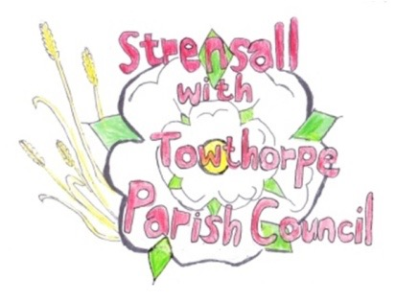
STRENSALL WITH TOWTHORPE PARISH COUNCIL
The Village Hall, Northfields, Strensall, York YO325XW

e-mail: strensalltowthorpePC@outlook.com phone: 01904 491569

MINUTES OF A PLANNING COMMITTEE MEETING HELD ON TUESDAY 12th OCTOBER 2021 AT 7.00PM

Councillors Present: Andrew Bolton Chris Chambers John Chapman Tony Fisher Ray Maher Lawrence Mattinson

In Attendance: Fiona Hill - Parish Clerk
Public Present: 0
- a) To receive apologies for absence given in advance of the meeting: None
b) To consider the approval of reasons given for absence: N/A

- To receive any declarations of interest under the Parish Council Code of Conduct or
Members register of interests: None

- To approve the minutes of the monthly Parish Council meeting of 28th September 2021: Resolved – Approved (Unanimous)

- To discuss any ongoing issues and information received:

21/01431/ADV – Tescos – Revised Drawings – Cllrs noted CYC had approved this application

AOD/21/00134 – Moorlands – Negotiations regarding the discharge of conditions are ongoing

- To consider and respond to consultations from City of York Council to the following
planning applications:
- 21/02221/FUL - Single storey rear extension @ 50 Moor Lane
Resolved – No Objection (Unanimous)

- To note planning decisions received:
- 21/01588/FUL – Single storey rear extension (retrospective) @ 9 Shelley Drive – Approved

- To confirm date of next meeting as Tuesday 24th October 2021 @ 6.30 p.m. Resolved – Approved (Unanimous)

