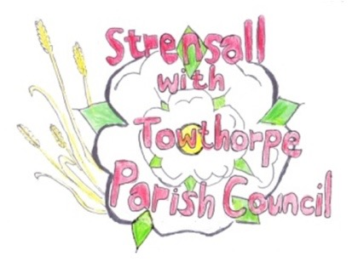**STRENSALL WITH TOWTHORPE PARISH COUNCIL**

The Village Hall, Northfields, Strensall, York YO325XW

e-mail: [strensalltowthorpePC@outlook.com](mailto:strensalltowthorpePC@outlook.com) phone: 01904 491569

**MINUTES OF A PLANNING COMMITTEE MEETING HELD ON TUESDAY 13 APRIL 2021 AT 6.30PM**

**Councillors Present:** Andrew Bolton Chris Chambers John Chapman Helen Cox Tony Fisher Lawrence Mattinson

**In Attendance:** Fiona Hill - Parish Clerk

**Public Present:** 0

1. **a) To receive apologies for absence given in advance of the meeting:** None

**b) To consider the approval of reasons given for absence:** N/A

1. **To receive any declarations of interest under the Parish Council Code of Conduct or**

**Members register of interests:** None

1. **To approve the minutes of the monthly Parish Council meeting of 23rd March 2021:** Resolved – Approved (Unanimous)
2. **To discuss any ongoing issues and information received:** Noted
3. AOD/21/00089 – Discharge of conditions 1 - 5 of 20/02128/FUL @ 2 The Willows
4. AOD/21/00076 – Discharge of condition 4 (Details of the means of enclosure to be submitted and removal of permitted development rights) of planning permission 20/00268/FUL @ 2 Hawthorne Mews
5. **To consider and respond to consultations from City of York Council to the following**

**planning applications:**

1. 21/00639/FUL - Single storey rear extension following partial demolition of existing single storey offshoot @ York Cottage 47 The Village

The Parish Council has No Objections (Unanimous), but are concerned about access to rear garden and possible issues with bin storage

1. 21/00659/LHE - Erection of single storey extension extending 4.6 metres beyond the rear wall of the original house, with a height to the eaves of 2.5 metres and a total height of 3.9 metres @ 24 Melcombe Avenue

The Parish Council has No Objections (Unanimous)

1. 21/00755/FUL - Single storey side extension, porch to front @ 21 Waincroft

The Parish Council has No Objections (Unanimous)

1. 21/00789/TPO - Crown lift Oak protected by Tree Preservation Order no. 131/1989 @ 9 Oak Tree Way

The Parish Council has No Objections (Unanimous) and will be guided by the City of York Tree Officer, as work should not jeopardize the long-term survival of the tree

1. 21/00821/TCA - Fell 2no. Ash trees in a Conservation Area @ Ash Tree House Southfields Road

The Parish Council has No Objections (Unanimous), but would request that the applicant plants suitable species replacement trees

1. **To note planning decisions received:**

a) 21/00437/TCA - Remove deadwood and 2no. stems from an Ash tree in the

Conservation Area @ 129 The Village – Consented

1. **To confirm date of next meeting as Tuesday 27th April 2021 @ 6.30 p.m. Resolved** – Agreed