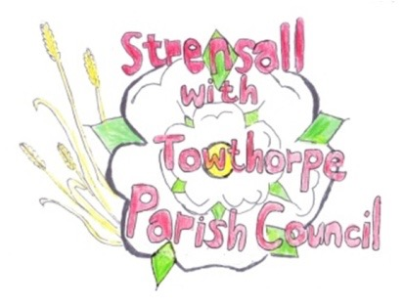
STRENSALL WITH TOWTHORPE PARISH COUNCIL
The Village Hall, Northfields, Strensall, York YO325XW

e-mail: strensalltowthorpePC@outlook.com phone: 01904 491569

MINUTES OF A PLANNING COMMITTEE MEETING HELD ON TUESDAY 14th SEPTEMBER 2021 AT 6.45PM

Councillors Present: Andrew Bolton Chris Chambers John Chapman Tony Fisher Ray Maher

In Attendance: Fiona Hill - Parish Clerk
Public Present: 0
- a) To receive apologies for absence given in advance of the meeting: Lawrence Mattinson
b) To consider the approval of reasons given for absence: Resolved – Approved (Unanimous)

- To receive any declarations of interest under the Parish Council Code of Conduct or
Members register of interests: None

- To approve the minutes of the monthly Parish Council meeting of 24th August 2021: Resolved – Approved (Unanimous)

- To discuss any ongoing issues and information received: Former Landfill Site, Brecks Lane – Cllr Chapman had emailed City of York Council and received a response as follows:
In response to your voicemail message, I can confirm that we have no outstanding ground gas concerns at the Brecks Lane site. The most recent round of gas monitoring (carried out in 2015) showed that the majority of readings taken from the perimeter of the landfill were below the threshold levels of 1% methane and 5% carbon dioxide. In addition, no gas flow was detected, which suggests that the decomposition of organic material within the landfill may be nearing completion. These results indicate that the risk to residents is very small indeed. The prospective buyer did not contact us regarding this, so I’m not sure where they got their information from. Please feel free to pass on my contact details to your neighbour and let them know that I’d be happy to discuss this with them or their prospective buyer. Kind regards, Lucie Lucie Watson | Senior Contaminated Land Officer (Wed – Fri) t: 01904 551533 | e: lucie.watson@york.gov.uk City of York Council, Public Protection, Eco Depot, Hazel Court, James Street, York, YO10 3DS

- To consider and respond to consultations from City of York Council to the following
planning applications: - 21/01969/FUL – Removal of chimney @ 9 Redmayne Square Resolved – Objection (Unanimous) Comment: This application is contrary to our submitted Neighbourhood Plan and approved Village Design Statement. In addition, it confli cts with Supplementary Planning Guidance, which would set a negative precedence, which would affect the street scene. The Parish Council would advise that the use of Gallows Brackets would achieve the same objective, without removal of the external part of the chimney stack
- 21/01989/FUL – Single storey annex to front @ 60 Moor Lane Resolved – No Objection (Unanimous) The Parish Council would insist that subsequent use is by the occupiers of 60 Moor Lane only and the annex cannot be used for subletting, holiday letting, commercial letting etc

- To note planning decisions received: 21/01474/FUL - Single storey extension @ 50 Fossview Close – Approved
21/01496/FUL - Two storey side extension, single storey rear extension, porch to front and alterations to existing garage roof pitch @ 2 Newton Way – Approved
21/01577/FUL - Single storey rear link extension and partial conversion of garage with raising of roof to form additional living accommodation and guest bedroom @ 10 Chaucer Lane - Approved
21/01597/FUL - Single and two storey rear extension @ 1 Chaucer Lane – Approved
21/01606/FUL - Change of use of garage to beauty treatment room (sui generis) @ 47 Riverside Walk – Approved
21/01621/FUL - Single storey side and rear extension following demolition of conservatory @ 65 Middlecroft Drive - Approved
21/01738/TPO - Crown clean and crown reduce Oak by 30% - protected by Tree Preservation Order no. 131/1989 @ 15 Oak Tree Way – Refused
21/01916/NONMAT - Non-material amendment to permitted application 20/02183/FUL to include alterations to windows, elevation treatments and addition of canopy @ The Hawthorns Lords Moor Lane - Refused

- To confirm date of next meeting as Tuesday 28th September 2021 @ 6.30 p.m. Resolved – Approved (Unanimous)

