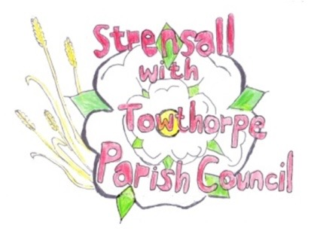
STRENSALL WITH TOWTHORPE PARISH COUNCIL
The Village Hall, Northfields, Strensall, York YO325XW

e-mail: strensalltowthorpePC@outlook.com phone: 01904 491569

MINUTES OF A PLANNING COMMITTEE MEETING HELD ON TUESDAY 23 FEBRUARY 2021 AT 6.30PM
Councillors Present: Andrew Bolton Chris Chambers John Chapman Tony Fisher * Lawrence Mattinson

In Attendance: Fiona Hill - Parish Clerk
Public Present: 0
* City of York Council Strensall Ward Councillor
- a) To note apologies for absence and approve the reasons given: Cllr Dr Cox
b) To consider the approval of reasons given for absence:
Resolved – Approved (Unanimous)

- To receive any declarations of interest under the Parish Council Code of Conduct or
Members register of interests:
Cllr Bolton – The Hawthorns – Lives opposite and has previously objected

- To approve the minutes of the monthly Parish Council meeting of 26th January 2021: Resolved – Approved (Unanimous) (There had been no meeting Thu09Feb21)

- To discuss any ongoing issues and information received: - Revised plans – The Hawthorns, Lords Moor Lane Resolved - The Parish Council thanks the applicant for the modifications made, which addresses most of the issues it raised, however the drainage still remains a concern. Proposed: Cllr Fisher, seconded: Cllr Chamber, Unanimous

- To consider and respond to consultations from City of York Council to the following
planning applications:
- 21/00278/LHE - Erection of single storey extension extending 6.0 metres beyond the rear wall of the original house, with a height to the eaves of 2.8 metres and a total height of 2.8 metres @ 8 Kirklands
Resolved – The Parish Council has No Objections, but queries if this should be dealt with via an FUL rather than a LHE planning application, due to previous planning applications in 1997 and 04/00600/FUL

- 21/00372/TCA - Fell 1no. Ash tree in a Conservation Area @ 129 The Village
This application had been withdrawn, so no further action would be taken

- To note planning decisions received: - 20/02128/FUL - Extension to existing single storey garage to create workshop and
garage at ground floor with home office, store and wc in roof space, 2no. dormers to east elevation, 1no. dormer to south elevation, 2no. rooflights to west elevation and 1no. rooflight to north elevation @ 2 The Willows – Approved
- 20/02271/FUL - Change of use of field to dog exercise area @ Brecks Lane Farm Brecks Lane – Approved
- 20/02367/FUL - Single storey side and rear extension following demolition of existing conservatory - 4 Ryecroft – Approved
- 20/02526/TCA - Fell 4no. Laurels and 1no. Apple tree in a Conservation Area @ The Sycamores, 12 The Village - Consented

- To confirm date of next meeting as Tuesday 09th March 2021 @ 6.30 p.m. Resolved – Agreed

