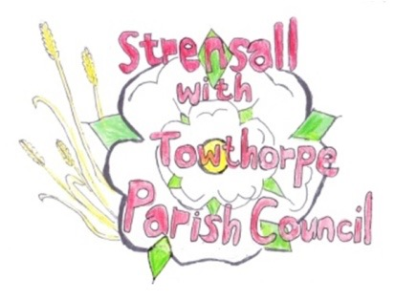
STRENSALL WITH TOWTHORPE PARISH COUNCIL
The Village Hall, Northfields, Strensall, York YO325XW

e-mail: strensalltowthorpePC@outlook.com phone: 01904 491569

MINUTES OF A PLANNING COMMITTEE MEETING HELD ON TUESDAY 23 MARCH 2021 AT 6.30PM

Councillors Present: Andrew Bolton Chris Chambers John Chapman Helen Cox Tony Fisher Lawrence Mattinson

In Attendance: Fiona Hill - Parish Clerk
Public Present: 0

- a) To receive apologies for absence given in advance of the meeting: None
b) To consider the approval of reasons given for absence: N/A

- To receive any declarations of interest under the Parish Council Code of Conduct or
Members register of interests:
5h - Cllr Chambers – Village Hall Committee

- To approve the minutes of the monthly Parish Council meeting of 09th March 2021: Resolved – Approved (Unanimous)

- To discuss any ongoing issues and information received: There was a brief discussion about application AOD/21/00052 and Cllr Chapman reported
that there are three letters of support on the planning portal

- To consider and respond to consultations from City of York Council to the following
planning applications:
a) 21/00447/FUL - Single storey rear extension, porch to front @ 32 Hollis Crescent Resolved – No Objection, but is concerned about the size of the development, leading to a loss of amenity space in the rear garden.

b) 21/00448/FUL - Two storey side and single storey rear extensions, and single storey outbuilding following demolition of garage @ 44 Middlecroft Drive
Resolved – No Objection

c) 21/00458/FUL - Single storey rear extension @ 95 The Village
Resolved – No Objection, but would like to see clarification on the loft conversion.

d) 21/00466/FUL - Replacement entrance door to front @ 18 The Village
Resolved – No Objection

e) 21/00545/TCA - Crown reduce 1no. Cherry and 1no. Crab Apple by 1m, crown reduce Apple tree by 2m; reduce overhanging branches from neighbouring Plum tree - tree works in a Conservation Area @ 60 The Village
Resolved – No Objection, will be guided by the City of York Council Tree Officer, but would request that the work is done by a qualified tree specialist.

f) 21/00563/FUL - Single storey rear extension (revised submission) @ 4 Princess Road
Resolved – No Objection, but would draw attention to historic flooding issues in close proximity.

g) 21/00590/TCA - Various pruning works to 5no. trees in a Conservation Area @ The Grange 59 The Village
Resolved – No Objection, will be guided by the City of York Council Tree Officer, but would request that the work is done by a qualified tree specialist.

h) Licensing application - Caseys Coffee to trade at Strensall Village Hall Car Park, (Letter of permission received from the landowner), Proposed trading: Monday and Friday 09:00- 15:00. The vessel proposes to sell hot and cold drinks, cakes and pastries between the hours listed above. Resolved – No Objection, but the applicant must provide their own litter bin, so the trade waste does not end up in the Parish Council and City of York Council bins. In addition, there is a Public Space Protection Order in place covering the parish of Strensall and Towthorpe, which is for the purpose of an alcohol restriction zone.
- To note planning decisions received: None

- To confirm date of next meeting as Tuesday 13th April 2021 @ 6.30 p.m. Resolved – Agreed

