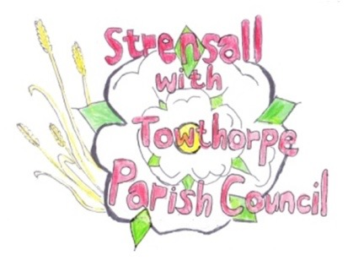
STRENSALL WITH TOWTHORPE PARISH COUNCIL
The Village Hall, Northfields, Strensall, York YO325XW

e-mail: strensalltowthorpePC@outlook.com phone: 01904 491569

MINUTES OF A PLANNING COMMITTEE MEETING HELD ON TUESDAY 24th AUGUST 2021 AT 6.30PM

Councillors Present: Andrew Bolton Chris Chambers John Chapman Tony Fisher Ray Maher Lawrence Mattinson

In Attendance: Fiona Hill - Parish Clerk
Public Present: 0

- a) To receive apologies for absence given in advance of the meeting: None
b) To consider the approval of reasons given for absence: N/A

- To receive any declarations of interest under the Parish Council Code of Conduct or
Members register of interests: Cllr Bolton – 21/01916/NONMAT – Lives directly opposite

- To approve the minutes of the monthly Parish Council meeting of 10th August 2021: Resolved – Approved (Unanimous)

- To discuss any ongoing issues and information received: 21/0916/NONMAT – Non-material amendment to permitted application 20/02183/FUL to include alterations to windows, elevation treatments and addition of canopy @ The Hawthorns, Lords Moor Lane The Parish Council is concerned about the lack of detail regarding the type and treatment of the timber cladding.

- To consider and respond to consultations from City of York Council to the following
planning applications:
- 21/01734/FUL – Siting of one shepherd’s hut (and additional hut for shower and wc) to be used as holiday accommodation @ Cow Slip Farm, Lords Moor Lane
Resolved – The Parish Council has No Objections, but it notes mention of application 19/01208/FUL and recommends that for consistency the same conditions are applied, if you are minded to approve. (Unanimous)

- To note planning decisions received: 21/01566/LHE - Erection of single storey extension extending 4.3 metres beyond the rear wall of the existing enlargement, with a total enlargement of 6.3 metres, height to the
eaves of 2.85 metres and a total height of 3.9 metres @ 50 Moor Lane - Refused

- To confirm date of next meeting as Tuesday 14th September 2021 @ 6.30 p.m. Resolved – Approved (Unanimous)

