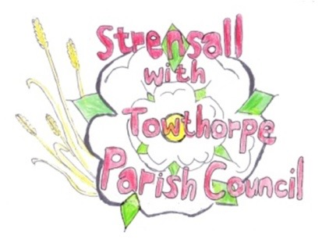**STRENSALL WITH TOWTHORPE PARISH COUNCIL**

The Village Hall, Northfields, Strensall, York YO325XW

e-mail: [strensalltowthorpePC@outlook.com](mailto:strensalltowthorpePC@outlook.com) phone: 01904 491569

**MINUTES OF A PLANNING COMMITTEE MEETING HELD ON TUESDAY 26th OCTOBER 2021 AT 6.30PM**

**Councillors Present:** John Chapman Tony Fisher Lawrence Mattinson

**In Attendance:** Fiona Hill - Parish Clerk

**Public Present:** 0

1. **a) To receive apologies for absence given in advance of the meeting:**  Andrew Bolton and Chris Chambers

**b) To consider the approval of reasons given for absence:** Resolved – Approved (Unanimous)

1. **To receive any declarations of interest under the Parish Council Code of Conduct or**

**Members register of interests:** None

1. **To approve the minutes of the monthly Parish Council meeting of 12th October 2021:** Resolved – Approved (Unanimous)
2. **To discuss any ongoing issues and information received:**

Country Park – Appeal dismissed

1. **To consider and respond to consultations from City of York Council to the following**

**planning applications:** 21/02274/FUL - Single storey rear extension following demolition of existing conservatory @ 3 Waltham Close

Resolved – No Objections (Unanimous)

1. **To note planning decisions received:**

21/01431/ADV - Display of 1no. internally illuminated fascia sign and 1no. internally illuminated projecting sign @ Tesco, 40 The Village - Approved

21/02075/TCA - Various tree works including the felling of 1no. Beech and 1no. Horse Chestnut in a Conservation Area @ Manor Farm, 1 The Village - Consented

1. **To confirm date of next meeting as Tuesday 09th November 2021 @ 6.30 p.m.** Resolved – Approved (Unanimous)