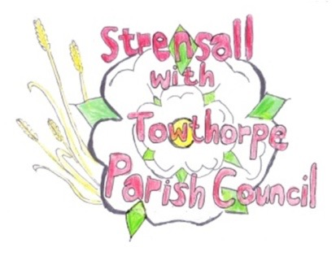
STRENSALL WITH TOWTHORPE PARISH COUNCIL
The Village Hall, Northfields, Strensall, York YO325XW

e-mail: strensalltowthorpePC@outlook.com phone: 01904 491569

MINUTES OF A PLANNING COMMITTEE MEETING HELD ON TUESDAY 27 APRIL 2021 AT 6.30PM

Councillors Present: Andrew Bolton Chris Chambers John Chapman Helen Cox Tony Fisher Lawrence Mattinson

In Attendance: Fiona Hill - Parish Clerk
Public Present: 1

- a) To receive apologies for absence given in advance of the meeting: None
b) To consider the approval of reasons given for absence: N/A

- To receive any declarations of interest under the Parish Council Code of Conduct or
Members register of interests: None

- To approve the minutes of the monthly Parish Council meeting of 13th April 2021: Resolved – Approved (Unanimous)

- To discuss any ongoing issues and information received: Noted
- AOD/21/00104 - Condition 9 and 13 - 19/02463/FULM - Foss Upstream Storage Area
- AOD/21/00109 - Condition 18 of 19/02463/FULM - Foss Upstream Storage Area

- To consider and respond to consultations from City of York Council to the following
planning applications:
a) 21/00776/FUL - Replacement ramp to static caravan to rear of 74 Northfields @ 74 Northfields

Resolved – No Objections (Unanimous)

b) 21/00889/FUL - Two storey side extension following demolition of existing garage @ 31 Wilkinson Way

Resolved – No Objections, in principle, but the Parish Council has concerns about there no longer being a route for bins to rear of the property, so this could result in bins left at the front of the property, contrary to Supplementary Planning Documentation.
c) 21/00896/TPO - Crown lift Oak tree to 8 metres; reduce lateral branches to shape - protected by Tree Preservation Order no. 131/1989 @ 9 Oak Tree Way

This application was withdrawn before the meeting, so no action was taken.

- To note planning decisions received:
- 21/00392/FUL - Two storey side extension following demolition of car port/store @ 22 Ryecroft - Approved

- 21/00545/TCA - Crown reduce 1no. Cherry and 1no. Crab Apple by 1m, crown reduce Apple tree by 2m; reduce overhanging branches from neighbouring Plum tree - tree works in a Conservation Area @ 60 The Village – Consented

- 21/00590/TCA - Various pruning works to 5no. trees in a Conservation Area @ The Grange, 59 The Village – Consented

- 21/00448/FUL - Two storey side and rear extension, single storey rear extensions, and single storey outbuilding following demolition of garage @ 44 Middlecroft Drive – Approved

- 21/00283/FUL - Railings and gate to front - York Cottage, 47 The Village @ Approved

- To confirm date of next meeting as Tuesday 11th May 2021 @ 6.30 p.m. Resolved – Agreed, subject to Covid legislation

