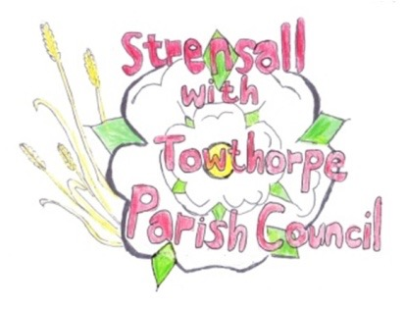
STRENSALL WITH TOWTHORPE PARISH COUNCIL
The Village Hall, Northfields, Strensall, York YO325XW

e-mail: strensalltowthorpePC@outlook.com phone: 01904 491569

MINUTES OF A PLANNING COMMITTEE MEETING HELD ON TUESDAY 28th SEPTEMBER 2021 AT 6.45PM

Councillors Present: Andrew Bolton Chris Chambers John Chapman Tony Fisher Ray Maher Lawrence Mattinson

In Attendance: Fiona Hill - Parish Clerk
Public Present: 0
- a) To receive apologies for absence given in advance of the meeting: None
b) To consider the approval of reasons given for absence: N/A

- To receive any declarations of interest under the Parish Council Code of Conduct or
Members register of interests: None

- To approve the minutes of the monthly Parish Council meeting of 14th September 2021: Resolved – Approved (Unanimous)

- To discuss any ongoing issues and information received: None

- To consider and respond to consultations from City of York Council to the following
planning applications:
- 21/02042/FUL - First floor side extension, single storey rear extension and porch to front @ 8 Hallard Way

Resolved – Objection (Unanimous)

The Parish Council objects as this is overdevelopment of the plot and the extension is not sub-servient to the main dwelling, which is contrary to the draft Supplementary Planning Document.

The Parish Council will not allow access to the rear of the property via the Open Space

- 21/02055/FUL - Single storey side extension @ 14 Knapton Close

Resolved – No Objections (Unanimous)

The Parish Council will not allow access to the rear of the property via the Open Space
- 21/02075/TCA - Various tree works including the felling of 1no. Beech and 1no. Horse Chestnut in a Conservation Area @ Manor Farm, 1 The Village

Resolved – No Objection (Unanimous)

Subject to all works being done under the guidance of City of York Council Tree Officer

- 21/02083/FUL - Single storey rendered rear extension and porch to front @ 15 Oak Tree Way

Resolved – No Objections (Unanimous)

No Comments

- 21/02096/FUL - Extension to rear with balcony, installation of 7no. additional rooflights to side elevations, alterations to existing windows, render to existing dwelling and extension and new slate roof @ 25 Moor Lane

Resolved – No Objections (Four votes in favour and two votes against)
The Parish Council is concerned about the status of the balcony and the loss of amenity due to overlooking of neighbours.

- To note planning decisions received:
- 20/00732/FUL - Erection of building for vehicle repairs and storage following the demolition of the existing building @ Ward Cars, New Lane - Refused
- 21/01016/FUL - Two storey side and rear extension, single storey side and rear extensions and bay window to front with pitched roof @ 40 Middlecroft Drive - Approved
- 21/01734/FUL - Change of use of land for siting of one occupied shepherd's hut (and additional hut for shower and wc) to be used as holiday accommodation @ Cow Slip Farm Lords Moor Lane - Approved
- 21/01821/FUL - Single storey front extension after demolition of existing porch @ 36 Melcombe Avenue - Approved

- To confirm date of next meeting as Tuesday 12th October 2021 @ 6.30 p.m. Resolved – Approved (Unanimous)

