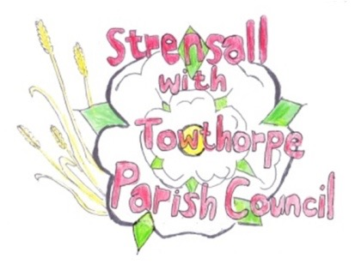
STRENSALL WITH TOWTHORPE PARISH COUNCIL
The Village Hall, Northfields, Strensall, York YO325XW

e-mail: strensalltowthorpePC@outlook.com phone: 01904 491569

MINUTES OF A PLANNING COMMITTEE MEETING HELD REMOTELY ON TUESDAY 10 NOVEMBER 2020 AT 6.30PM

Councillors Present: Andrew Bolton Chris Chambers John Chapman Dr Helen Cox Tony Fisher * Lawrence Mattinson

In Attendance: Fiona Hill (FH) - Parish Clerk
Public Present: 0
* City of York Council Strensall Ward Councillor
- To note apologies for absence and approve the reasons given:
Cllr Tony Gavin

- To receive any declarations of interest under the Parish Council Code of Conduct or
Members register of interests:
Cllr Fisher – 20/02052/FUL – has spoken to the applicant about his planning – he left the meeting whilst this agenda item was discussed.

- To approve the minutes of the monthly Parish Council meeting of 27th October 2020: Resolved – Approved (Unanimous)

- To discuss any ongoing issues and information received - NTR

- To consider and respond to consultations from City of York Council to the following
planning applications:

- 20/02004/FUL - Single storey rear extension, hipped to gable roof with enlarged dormer to rear @ 27 Moor Lane
Resolved – The Parish Council has No Objections (Unanimous)

- 20/02047/FUL - Two storey rear extension with 1no. rooflight to side elevation @ 7 Simons Close
Resolved – The Parish Council has No Objections (Unanimous)

- 20/02052/FUL - Extension to rear of garage @ 2 Riverside Walk
Resolved – The Parish Council has No Objections, as long as the physio room is for personal use only. The applicant should be made aware of the Party Wall Act, as it appears the footings will encroach on to the neighbours property. Should the physio room ever be required for commercial use, then a further application should be made, as there would many issues to discuss. (Unanimous)

- 20/02074/TPO - Crown lift Lime tree protected by Tree Preservation Order no. 1975/1 @ 17 York Road
Resolved – The Parish Council has No Objections, as these works are preferable to felling, however;
- The tree is valuable to the street scene on York Road, so the work should be done by a qualified tree surgeon to BS 3998 2010
- Only minimal works should be done, which strictly comply with the instructions of the City of York Council Tree Officer
(Unanimous)

- To note planning decisions received:
- 20/01307/FUL – Single storey rear extension @ 4 Princess Road – Approved

- To confirm date of next meeting as Tuesday 24th November 2020 @ 6.30 p.m. Resolved – Agreed

