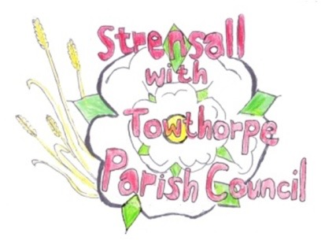
STRENSALL WITH TOWTHORPE PARISH COUNCIL
The Village Hall, Northfields, Strensall, York YO325XW

e-mail: strensalltowthorpePC@outlook.com phone: 01904 491569

MINUTES OF A PLANNING COMMITTEE MEETING HELD REMOTELY ON TUESDAY 13 OCTOBER 2020 AT 6.30PM

Councillors Present: Andrew Bolton John Chapman Dr Helen Cox Tony Fisher * Tony Gavin Lawrence Mattinson

In Attendance: Fiona Hill (FH) - Parish Clerk
Public Present: 0
* City of York Council Strensall Ward Councillor
- To note apologies for absence and approve the reasons given:
Cllr Chris Chambers

- To receive any declarations of interest under the Parish Council Code of Conduct or
Members register of interests:
Cllr Fisher, as a member of the CYC Planning Committee would not express an opinion on new planning applications

- To approve the minutes of the monthly Parish Council meeting of 22nd September 2020: Resolved – Approved (Unanimous)

- To discuss any ongoing issues and information received -
New Lane - The Parish Council noted comments by agent, which were on the planning portal.

- To consider and respond to consultations from City of York Council to the following
planning applications:
- 20/01623/FUL - Two storey side extension and single storey rear extension @ 9 Stuart Close
Resolved – Whilst the Parish Council has No Objections, in principle, the vague application, which lacks detail (e.g. materials), is open to a lot of interpretation, which will be difficult to enforce. (Unanimous)

- 20/01771/FUL - Partial conversion and change of use of existing garage into hairdressing business (Use Class E) with associated alterations including installation of door, 2no. windows and 1no. rooflight @ 8 Shelley Drive
Resolved – Not wishing to stifle local enterprise, the Parish Council Objects to this application, as it has serious reservations about statements within the application form, see sections 2, 11, 13, 15, 20 and 23. In addition, the Parish Council is concerned about increased traffic post Covid19, parking and disposal of commercial waste. (Unanimous)

- 20/01819/TPO - Fell Lime tree protected by Tree Preservation Order no. 1975/1 @ 17 York Road
Resolved – The Parish Council Strongly Objects to the felling of this tree, as there is insufficient evidence to justify this work. Minor dead wooding would be acceptable, to be done by a qualified tree specialist, under the direction of the City of York Council Tree Officer (Unanimous)

- 20/01909/TPO - Crown reduce canopy height and spread of Oak tree to previous reduction points, up to 2m - protected by Tree Preservation Order no. 131/1989 @ Deans Oak 21 Oak Tree Close
Resolved – The Parish Council has No Objections and will be guided by the City of York Council Tree Officer

- To note planning decisions received:

- 20/01329/FUL - Single storey rear extension @ 27 Riverside Walk - Approved

- 20/01463/FUL - Porch to front (revised scheme, resubmission) @ Holme Lodge, 1 Holme Lea - Approved

- To confirm date of next meeting as Tuesday 27th October 2020 @ 6.30 p.m. Resolved – Agreed

