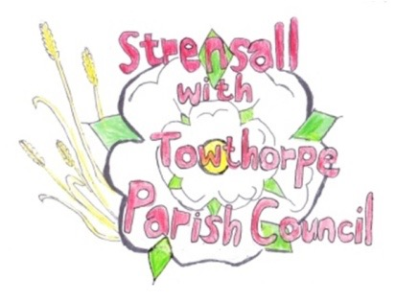
STRENSALL WITH TOWTHORPE PARISH COUNCIL
The Village Hall, Northfields, Strensall, York YO325XW

e-mail: strensalltowthorpePC@outlook.com phone: 01904 491569

MINUTES OF A PLANNING COMMITTEE MEETING HELD REMOTELY ON TUESDAY 22 SEPTEMBER 2020 AT 6.30PM

Councillors Present: Andrew Bolton Chris Chambers John Chapman Dr Helen Cox Tony Fisher * Tony Gavin
Lawrence Mattinson

In Attendance: Fiona Hill (FH) - Parish Clerk
Public Present: 0
* City of York Council Strensall Ward Councillor
- To note apologies for absence and approve the reasons given: None

- To receive any declarations of interest under the Parish Council Code of Conduct or
Members register of interests:
20/01667/FUL - Cllr Mattinson had received a letter from CYC
Cllr Fisher, as a member of the CYC Planning Committee would not express an opinion on new planning applications

- To approve the minutes of the monthly Parish Council meeting of 08th September 2020: Resolved – Approved (Unanimous)

- To discuss any ongoing issues and information received -

73 Barley Rise - CYC Planning Enforcement are now investigating what appears to be an unauthorised rear extension.

- To consider and respond to consultations from City of York Council to the following
planning applications:
20/01594/FUL – Single storey rear extension with canopy, and porch to front @ 4 Bonneycroft
Resolved – The Parish Council has No Objections (Unanimous). The Parish Council felt the standard of the plans was outstanding, as all too often plans submitted were of an inadequate standard to make a judgement.
20/01667/FUL - Two storey side extension, enlarged dormer to side, bay window to front, render finish to existing dwelling, replacement roof and windows throughout @ Candovers, 16 York Road
Resolved – The Parish Council had No Objections, in principle, but was concerned that the dormer would dominate the house, which conflicts with section 14.5 of the Supplementary Planning Guidance December 2012, as the application site is in Conservation area 23, so the views of the conservation officer must be sought. (Unanimous).

- To note planning decisions received:
20/01289/FUL - Two storey rear and single storey side extension following demolition of conservatory @ 10 Tyneham Way – Refused

20/01301/FUL - Alterations and extensions of bungalow to create a two storey house, with two storey side extension, single storey rear extension, single storey front extension, 14no. solar panels to roof, and single storey side extension to single garage and installation pitched roof over @ 58 Barley Rise - Approved

20/01442/TPO - Fell 1no. Ash and 1no. Holly protected by Tree Preservation Order no. CYC53 @ 7 Bonneycroft – Consented

20/01292/FUL - Single storey rear extension @ 6 Oakhill Crescent - Approved
20/00639/FUL - Erection of 3no. single storey dwellings with associated parking and landscaping following demolition of existing buildings @ Manor Farm 1 The Village – Approved

- To confirm date of next meeting as Tuesday 13th October 2020 @ 6.30 p.m. Resolved – Agreed

