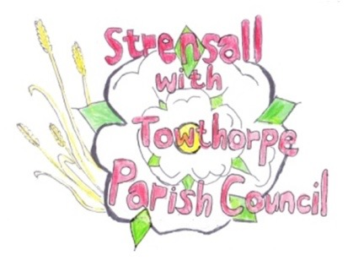
STRENSALL WITH TOWTHORPE PARISH COUNCIL
The Village Hall, Northfields, Strensall, York YO325XW

e-mail: strensalltowthorpePC@outlook.com phone: 01904 491569

MINUTES OF A PLANNING COMMITTEE MEETING HELD REMOTELY ON TUESDAY 27 OCTOBER 2020 AT 6.30PM

Councillors Present: Andrew Bolton Chris Chambers John Chapman Dr Helen Cox Tony Fisher * Lawrence Mattinson

In Attendance: Fiona Hill (FH) - Parish Clerk
Public Present: 0
* City of York Council Strensall Ward Councillor
- To note apologies for absence and approve the reasons given:
Cllr Tony Gavin

- To receive any declarations of interest under the Parish Council Code of Conduct or
Members register of interests:
None

- To approve the minutes of the monthly Parish Council meeting of 13th October 2020: Resolved – Approved (Unanimous)

- To discuss any ongoing issues and information received -
- 20/01819/TPO – Fell Lime tree protected by Tree Preservation Order no. 1975/1 @ 17 York Road – withdrawn before response was submitted
- 4 Princess Road, revised drawings, noted and will be on agenda of next meeting
- New Lane – comments from the City of York Council Flood Risk Management Team and Footpaths Officer were noted by the Parish Council

- To consider and respond to consultations from City of York Council to the following
planning applications:
- 20/01930/TCA – Fell Conifer tree in a Conservation Area @ 69 The Village
Resolved – The Parish Council has No Objections, but would like to see another tree planted within the premises. (Unanimous)

- 20/01933/TCA – Fell Ash tree in a Conservation Area @ 3 Princess Road
Resolved – The Parish Council Objects to this application, as there is no tree surgeons report and it appears to be for cosmetic purposes only, which is unacceptable with such a well-established tree. If the tree officer is minded to approve this application, the Parish Council would like to see another tree planted within the premises. (Unanimous)

- 20/01952/FUL – First floor side extension @ 8 Brecks Lane
Resolved – The Parish Council has No Objections (Unanimous)

Cllr Fisher left the meeting

- To note planning decisions received:
- 20/00246/FUL - Change of use of land to garden curtilage (retrospective) - 3 Hawthorne Mews – Approved
- 20/00248/FUL - Change of use of land to garden curtilage (retrospective) - 4 Hawthorne Mews – Approved
- 20/01179/FUL - Single storey rear extension following demolition of porch, 1no. rooflight to front, dormer to rear, and replacement windows @ 28 The Village - Approved
- 20/01526/FUL - Two storey rear extension following demolition of conservatory - 27 Chaucer Lane – Approved
- 20/01594/FUL - Single storey rear extension with canopy, and porch to front @ 4 Bonneycroft - Approved

Cllr Fisher re-joined the meeting

- To confirm date of next meeting as Tuesday 10th November 2020 @ 6.30 p.m. Resolved – Agreed

