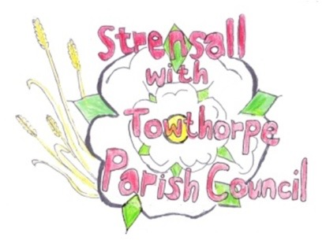
STRENSALL WITH TOWTHORPE PARISH COUNCIL
The Village Hall, Northfields, Strensall, York YO325XW

e-mail: strensalltowthorpePC@outlook.com phone: 01904 491569

NOTICE is hereby given that there will be a meeting of The Parish Council Trees, Allotments and Open Spaces Committee on Tuesday 22nd March 2022 at 7.15pm to be held in the Village Hall for the purpose of transacting the business shown on the Agenda below.
Members of the public and press are welcome to attend
Members of the Council are hereby summoned to attend

AGENDA

1. a) To receive apologies for absence given in advance of the meeting
b) To consider the approval of reasons given for absence

2. To receive any declarations of interest under the Parish Council Code of Conduct and Register of Interests

3. To approve the minutes of the committee meeting of Tuesday 25th January 2022

4. To discuss issues regarding Trees, including, but not restricted to items listed below:
- Year Two – Quotes received - Award contract
- Queens 70th Anniversary Tree – W.I. Committee
- Additional Tree works – Qoute from Tim Preston

5. To discuss issues regarding Allotments, including, but not restricted to items listed below:

6. To discuss issues regarding Open Spaces, including, but not restricted to items listed below:
- Leyfield Close - Wild Flowering – Update

7. To confirm dates of the next meeting as Tuesday 22nd March 2022 at 7.15 p.m.

Fiona Hill - Clerk to the Parish Council 16th March 2022

