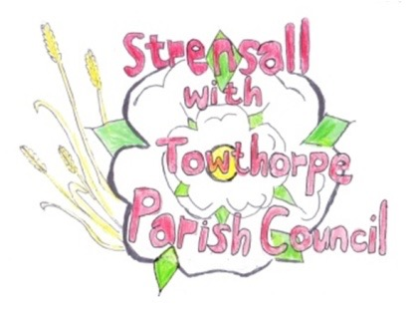
STRENSALL WITH TOWTHORPE PARISH COUNCIL
The Village Hall, Northfields, Strensall, York YO325XW
e-mail: strensalltowthorpePC@outlook.com phone: 01904 491569

NOTICE is hereby given that there will be a Planning Committee meeting of The Parish Council Planning Committee on Tuesday 22nd March 2022 at 6.30 pm to be held in the Village Hall for the purpose of transacting the business shown on the Agenda below.
Members of the public and press are welcome to attend
Members of the Council are hereby summoned to attend

AGENDA

1. a) To receive apologies for absence given in advance of the meeting:
b) To consider the approval of reasons given for absence:

2. To receive any declarations of interest under the Parish Council Code of Conduct and Register of Interests

3. To approve the Minutes of 08th March 2022

4. To discuss any ongoing issues and information received:

5. To consider and respond to consultations from City of York Council to the planning applications as follows:

- 22/00449/FUL - Two storey and single storey side extension following demolition of garage @ 6 Coulson Close

- 22/00521/TPO - Fell 1no. Pine tree protected by Tree Preservation Order no. CYC230 @ 22 Moor Lane

- 22/00464/FUL - Raising of ridge height to facilitate loft conversion and partial rendering of external elevations @ Caerglow, Lords Moor Lane

6. To note planning decisions received:

- 22/00026/FUL - Replacement of cooler plant and erection of 2.4m high enclosure to rear @ Tesco 40 The Village - Approved

7. To confirm the date of the next meeting: - 12th April 2022 at 6.30pm

Fiona Hill - Clerk to the Parish Council 16th March 2022

