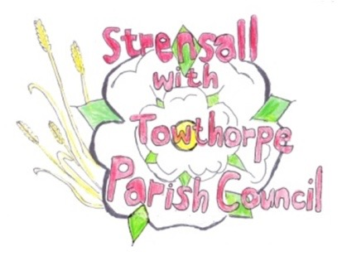**STRENSALL WITH TOWTHORPE PARISH COUNCIL**

The Village Hall, Northfields, Strensall, York YO325XW

e-mail: [strensalltowthorpePC@outlook.com](mailto:strensalltowthorpePC@outlook.com)

phone: 01904 491569

Chairman : Mr A H Fisher

**MINUTES OF AN PARISH COUNCIL MEETING HELD IN THE VILLAGE HALL ON THURSDAY 09th NOVEMBER 2021 AT 7.15PM**

**Councillors Present:** Chris Chambers John Chapman Tony Fisher* Ray Maher Susan Nunn Kevin Ogilvy

**In Attendance:** Fiona Hill - Parish Clerk

**Public Present:** 0

* City of York Councillors

1. **a) To receive apologies for absence given in advance of the meeting:** Parish Councillors Andrew Bolton and Lawrence Mattinson

Cllr Paul Doughty*

**b) To consider the approval of reasons given for absence:**

Resolved – Approved (Unanimous)

Cllr Hill’s absence from meetings for three months was approved at the October 2021 meeting

1. **To discuss the ordinary and casual vacancies:** Currently, no expressions of interest
2. **To receive any declarations of interest under the Parish Council Code of Conduct or**

**Members register of interests:** None

1. **a) To approve the minutes of the Parish Council meeting of 12th October 2021:**

Resolved – Approved (Unanimous)

**b) To endorse the approved Planning Committee minutes of 12th and 26th October 2021:**

Resolved – Approved (Unanimous)

1. **Public participation on any subject relating to the agenda:** None

**21/48 To receive matters raised by/with City of York Ward Councillors:** Cllr Fisher reported that Towthorpe Moor Lane would be resurfaced shortly and the Glebe Close road sign has been repaired.

**21/49 To discuss and, if necessary, agree action on matters arising/ongoing issues:** a)North Yorkshire Police monthly reports The October 2021 report had been circulated by email

**21/50 To discuss and, if necessary, agree action on matters raised since last meeting:** a)Queens 70th Anniversary Tree Cllr Fisher reported that the Women’s Institute wanted to plant a tree and the Parish Council would think about species and locations for the next meeting.

**21/51 To discuss and, if necessary, agree action, on any correspondence received:** a) Public Footpath Strensall 21 Modification Order 2021 City of York Council had written to confirm the above unopposed that the Definitive Map Modification Order recording a public footpath between The Village and Southfields Road. Cllr Fisher would request the surfacing is done.

**21/52 To discuss matters raised by/with Responsible Financial Officer (RFO):** a)Bank reconciliation, income received, payments made to date The Parish Clerk had circulated a financial report, which is shown below b) Internal controls checks Cllr Chapman conducted these checks and everything was found to be in order. c) Yorkshire Local Councils Association - NTR

**21/53 To confirm the date of the next meeting as Tuesday 14th December 2021 at 7.15 p.m.:** Resolved – Approved (Unanimous)

