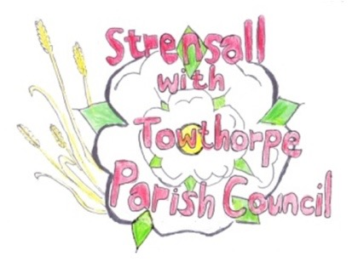
STRENSALL WITH TOWTHORPE PARISH COUNCIL

The Village Hall, Northfields, Strensall, York YO325XW
e-mail: strensalltowthorpePC@outlook.com
phone: 01904 491569
Chairman : Mr A H Fisher

MINUTES OF A PARISH COUNCIL MEETING HELD IN THE VILLAGE HALL ON THURSDAY 11th JANUARY 2022 AT 7.30PM
Councillors Present: Andrew Bolton Chris Chambers John Chapman Tony Fisher* Ray Maher Lawrence Mattinson Susan Nunn Kevin Ogilvy
In Attendance: Fiona Hill - Parish Clerk
Cllr Paul Doughty*
Public Present: 1
* City of York Councillors
- a) To receive apologies for absence given in advance of the meeting: None
b) To consider the approval of reasons given for absence: N/A

- To discuss the ordinary and casual vacancies: Currently, no new expressions of interest
The Parish Council thanked Duncan Hill, who had recently resigned, for all his work whilst a Councillor.

- To receive any declarations of interest under the Parish Council Code of Conduct or
Members register of interests: None

- a) To approve the minutes of the Parish Council meeting of 14th December 2021:
Resolved – Approved (Unanimous)
b) To endorse the approved Planning Committee minutes of 14th December 2021:
Resolved – Approved (Unanimous)

- Public participation on any subject relating to the agenda: None
21/81 To receive matters raised by/with City of York Ward Councillors: None
21/82 To discuss and, if necessary, agree action on matters arising/ongoing issues: a) North Yorkshire Police monthly reports The December 2021 report had not been received b) Queens 70th Anniversary Tree The W.I. committee would meet on site with Counciilors at the proposed site.
21/83 To discuss and, if necessary, agree action on matters raised since last meeting: a) Request for salt bin at Station Square The Parish Council discussed their current criteria. There are currently eighteen salt bins. Some were adopted from City of York Council. Others were purchased for areas with slopes or near village organisations e.g. doctors, library. Resolved – The Parish Council would not take any further action, as this area did not fulfil the criteria (7 votes in favour and 1 abstention – Cllr Fisher)
21/84 To discuss and, if necessary, agree action, on any correspondence received: None
21/85 To discuss matters raised by/with Responsible Financial Officer (RFO): a) Bank reconciliation, income received, payments made to date The Parish Clerk had circulated a financial report, which is shown below b) Internal controls checks Cllr Mattinson conducted these checks and everything was found to be in order. c) Yorkshire Local Councils Association - NTR
21/86 To confirm the date of the next meeting as Tuesday 08th February 2022 at 7.15 p.m.: Resolved – Approved (Unanimous)
21/87 To confirm the date of the Annual Parish Council Meeting as Tuesday 03rd May 2022 at 6.00 p.m.: Resolved – Approved (Unanimous)
21/88 To confirm the date of the Annual Parish Meeting as Tuesday 26th April 2022 at 7.15 p.m.: Resolved – Approved (Unanimous)
