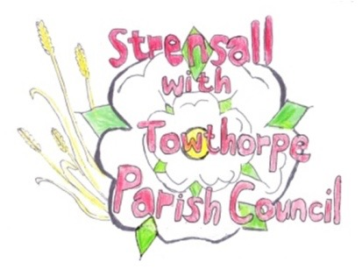**STRENSALL WITH TOWTHORPE PARISH COUNCIL**

The Village Hall, Northfields, Strensall, York YO325XW

e-mail: [strensalltowthorpePC@outlook.com](mailto:strensalltowthorpePC@outlook.com)

phone: 01904 491569

Chairman : Mr A H Fisher

**MINUTES OF AN PARISH COUNCIL MEETING HELD IN THE VILLAGE HALL ON THURSDAY 14th DECEMBER 2021 AT 7.15PM**

**Councillors Present:** Andrew Bolton Chris Chambers John Chapman Tony Fisher* Ray Maher Susan Nunn Kevin Ogilvy

**In Attendance:** Fiona Hill - Parish Clerk

Cllr Paul Doughty*

**Public Present:** 0

* City of York Councillors

1. **a) To receive apologies for absence given in advance of the meeting:** Parish Councillors and Lawrence Mattinson

**b) To consider the approval of reasons given for absence:**

Resolved – Approved (Unanimous)

Cllr Hill’s absence from meetings for three months was approved at the October 2021 meeting

1. **To discuss the ordinary and casual vacancies:** Currently, no expressions of interest
2. **To receive any declarations of interest under the Parish Council Code of Conduct or**

**Members register of interests:** Cllr Chambers – 21/72 b) Committee Member

1. **a) To approve the minutes of the Parish Council meeting of 09th November 2021:**

Resolved – Approved (Unanimous)

**b) To endorse the approved Planning Committee minutes of 09th and 23rd November 2021:**

Resolved – Approved (Unanimous)

1. **Public participation on any subject relating to the agenda:** None

**21/70 To receive matters raised by/with City of York Ward Councillors:** Cllr Doughty had received a request for a salt bin at Station Square, which would be added to the agenda for the next meeting. Cllrs Doughty/Fisher had both reported to CYC Planning Enforcement, the contravention of working hours conditioning at moorlands. Cllr Fisher gave an update on Haxby Station.

**21/71 To discuss and, if necessary, agree action on matters arising/ongoing issues:** a)North Yorkshire Police monthly reports The November 2021 report had not been received b) Queens 70th Anniversary Tree Resolved - The Parish Council agreed that it could be sited on Northfields Play Park, after removing the stump, of the tree that was felled. (Unanimous)

**21/72 To discuss and, if necessary, agree action on matters raised since last meeting:** a)Play Area weekly inspections Cllrs were reminded that if they couldn’t conduct their checks, it was their responsibility to find someone else to do them. Cllrs were asked to take a look at the wooden equipment, which was vulnerable to damage/decay. b) Strensall Community Group (Carnival/Christmas Bags/Community Brunch) – Grant Request Resolved – A grant of up to £1000.00 would be paid, on presentation to the Parish Council of evidence of expense. (Unanimous)

**21/73 To discuss and, if necessary, agree action, on any correspondence received:** None

**21/74 To discuss matters raised by/with Responsible Financial Officer (RFO):** a)Bank reconciliation, income received, payments made to date The Parish Clerk had circulated a financial report, which is shown below b) Budget 2022/2023 Resolved – A precept of £53000.00 and an expenditure budget of £60355.00 (Unanimous) b) Internal controls checks Cllr Nunn conducted these checks and everything was found to be in order. c) Yorkshire Local Councils Association - NTR

**21/75 To confirm the date of the next meeting as Tuesday 11th January 2022 at 7.15 p.m.:** Resolved – Approved (Unanimous)

