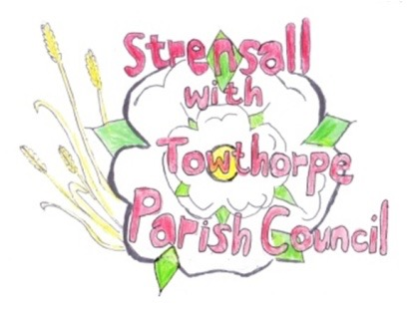**STRENSALL WITH TOWTHORPE PARISH COUNCIL**

The Village Hall, Northfields, Strensall, York YO325XW

e-mail: [strensalltowthorpePC@outlook.com](mailto:strensalltowthorpePC@outlook.com) phone: 01904 491569

**MINUTES OF A PLANNING COMMITTEE MEETING HELD ON TUESDAY 09th NOVEMBER 2021 AT 6.45PM**

**Councillors Present:** Chris Chambers John Chapman Tony Fisher Ray Mahers

**In Attendance:** Fiona Hill - Parish Clerk

**Public Present:** 0

1. **a) To receive apologies for absence given in advance of the meeting:**  Andrew Bolton and Lawrence Mattinson

**b) To consider the approval of reasons given for absence:** Resolved – Approved (Unanimous)

1. **To receive any declarations of interest under the Parish Council Code of Conduct or**

**Members register of interests:** None

1. **To approve the minutes of the monthly Parish Council meeting of 26th October 2021:** Resolved – Approved (Unanimous)
2. **To discuss any ongoing issues and information received:**

21/02096/FUL – 25 Moor Lane – Revised Drawings – Application now approved

River Foss Flood Scheme – All conditions discharged

4 York Road – Work done, but no application received

Moorlands – Demolition started, but not all conditions have been discharged

1. **To consider and respond to consultations from City of York Council to the following**

**planning applications:** 21/02352/TPO – Removal/reduction of branches from 1 no. Oak and 1 no. Ash protected by Tree Preservation Order no. CYC101 @ 1 The Birches, Moor Lane

Resolved – No Objections, subject to a qualified tree surgeon conducting the work, under the direction of the City of York Council Tree Surgeon (Unanimous)

1. **To note planning decisions received:**

21/01183/FUL - Two storey rear extension after demolition of existing single storey rear extension @ 6 The Village - Withdrawn

21/01969/FUL - Removal of chimney @ 9 Redmayne Square – Approved

21/02055/FUL - Single storey side extension @ 14 Knapton Close - Approved

1. **To confirm date of next meeting as Tuesday 23rd November 2021 @ 6.30 p.m.** Resolved – Approved (Unanimous)