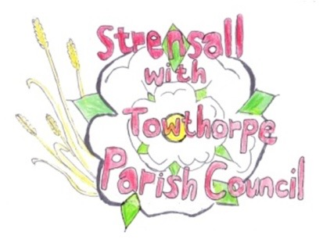
STRENSALL WITH TOWTHORPE PARISH COUNCIL
The Village Hall, Northfields, Strensall, York YO325XW
e-mail: strensalltowthorpePC@outlook.com phone: 01904 491569

MINUTES OF A PLANNING COMMITTEE MEETING HELD ON TUESDAY 14th DECEMBER 2021 AT 6.30PM
Councillors Present: Andrew Bolton Chris Chambers John Chapman Tony Fisher Ray Maher
In Attendance: Fiona Hill - Parish Clerk
Public Present: 0
- a) To receive apologies for absence given in advance of the meeting: Lawrence Mattinson
b) To consider the approval of reasons given for absence: Resolved – Approved (Unanimous)

- To receive any declarations of interest under the Parish Council Code of Conduct or
Members register of interests: Cllr Fisher – 21/02546/FUL – Applicant well known to Cllr

- To approve the minutes of the monthly Parish Council meeting of 23rd November 2021: Resolved – Approved (Unanimous)

- To discuss any ongoing issues and information received: None

- To consider and respond to consultations from City of York Council to the following
planning applications:
a) 21/02536/FUL - Single storey rear extension @ 27 Park Gate
Resolved – Neutral Response, No Objections (Unanimous)

b) 21/02537/FUL - Conversion of existing garage to dog grooming room (use class E) @ 37 Riverside Walk
Resolved – Neutral Response, No Objections, but would ask that conditions are applied: a) regarding hours of operation and waste disposal, similar to application 20/01771/FUL
b) regarding the safety of traffic management, so close to a well used snicket (Unanimous)
c) 21/02546/FUL - Hip to gable roof extensions to both sides with dormers to front and rear @ Caldie, West End
Resolved – Neutral Response, No Objections, but would ask the Planning Officer to take into account the letters of objection from neighbours (Unanimous)

d) 21/02584/FUL - Conversion of existing garage into habitable area @ 6 Melcombe Avenue
Resolved – Neutral Response, No Objections (Unanimous)

- To note planning decisions received:
20/00001/HH - High hedge investigation @ 49 Durlston Drive – Decision Made
b) 21/02042/FUL - First floor side extension, single storey rear extension and porch to front @ 8 Hallard Way - Approved
c) 21/02221/FUL - Single storey rear extension @ 50 Moor Lane – Approved

d) 21/02274/FUL - Single storey rear extension following demolition of existing conservatory @ 3 Waltham Close

e) 21/02352/TPO - Removal/reduction of branches from 1no. Oak and 1no. Ash protected by Tree Preservation Order no. CYC101 @ 1 The Birches, Moor Lane – No Objections

21/78 To confirm date of next meeting as Tuesday 11th January 2022 @ 6.30 p.m. Resolved – Approved (Unanimous)

