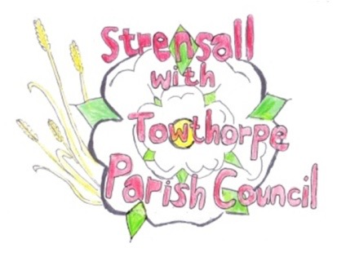
STRENSALL WITH TOWTHORPE PARISH COUNCIL
The Village Hall, Northfields, Strensall, York YO325XW
e-mail: strensalltowthorpePC@outlook.com phone: 01904 491569

MINUTES OF A PLANNING COMMITTEE MEETING HELD ON TUESDAY 22nd FEBRUARY 2022 AT 6.30PM
Councillors Present: Andrew Bolton Chris Chambers John Chapman Tony Fisher Ray Maher Lawrence Mattinson
In Attendance: Fiona Hill - Parish Clerk
Public Present: 0
- a) To receive apologies for absence given in advance of the meeting: None
b) To consider the approval of reasons given for absence: N/A

- To receive any declarations of interest under the Parish Council Code of Conduct or
Members register of interests: None

- To approve the minutes of the monthly Parish Council meeting of 08th February 2022: Resolved – Approved (Unanimous)

- To discuss any ongoing issues and information received: None

- To consider and respond to consultations from City of York Council to the following
planning applications:

- 21/02714/FUL - Removal of existing conservatory and installation of 2no. French doors to rear, relocation of garage doors to front @ Middleton House, 2 Redmayne Square
Resolved – No Objections (Unanimous)

- 21/02716/FUL - Erection of 1no. 2 storey dwelling (resubmission of 16/01199/FUL with design alterations) @ Middleton House, 2 Redmayne Square
Resolved – No Objections (Unanimous)

- 22/00187/FUL - Single storey side and rear extension @ 12 Moorland Garth
Resolved – No Objections (Unanimous)

- 22/00319/TCA - Fell 1no. Norway Spruce; crown lift 1no. Himalayan Birch - tree works in a Conservation Area @ 18 The Village
Resolved – No Objections (Unanimous)
The Parish Council regrets the loss of another tree, for no obvious reason and whilst it will be guided by the CYC Tree Officer, it would urge pruning, rather than felling.

- To note planning decisions received:
- 21/00725/FUL - Erection of detached dwelling to side/west of 12 The Village following the demolition of 2no. single storey extensions and front garden wall @ The Sycamores 12 The Village – Refused

- 21/01989/FUL - Single storey annex to side and rear elevation including alterations to the roof of the attached garage @ 60 Moor Lane - Approved

- 21/02680/FUL - Two storey and single storey rear extension, dormer extension to front and render to front and partial sides @ 4 Oak Tree Way - Approved

21/113 To confirm date of next meeting as Tuesday 08th March 2022 @ 6.30 p.m. Resolved – Approved (Unanimous)

