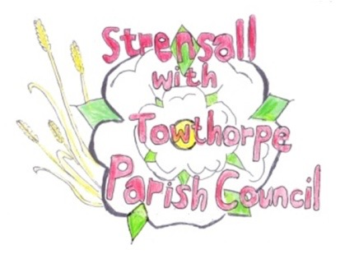
STRENSALL WITH TOWTHORPE PARISH COUNCIL
The Village Hall, Northfields, Strensall, York YO325XW
e-mail: strensalltowthorpePC@outlook.com phone: 01904 491569

MINUTES OF A PLANNING COMMITTEE MEETING HELD ON TUESDAY 23th NOVEMBER 2021 AT 6.30PM
Councillors Present: Andrew Bolton Chris Chambers John Chapman Ray Maher Lawrence Mattinson
In Attendance: Fiona Hill - Parish Clerk
Public Present: 0
- a) To receive apologies for absence given in advance of the meeting: Tony Fisher
b) To consider the approval of reasons given for absence: Resolved – Approved (Unanimous)

- To receive any declarations of interest under the Parish Council Code of Conduct or
Members register of interests: None

- To approve the minutes of the monthly Parish Council meeting of 09th November 2021: Resolved – Approved (Unanimous)

- To discuss any ongoing issues and information received:
Moorlands – Demolition continues, but not all conditions have been discharged. The CYC Tree Officer had visited the site.

- To consider and respond to consultations from City of York Council to the following
planning applications:
- 21/02434/FUL - Erection of new troop shelter and demolition of existing Nissen Hut on 'A' Range @Landmarc Support Services Ltd Building 70 Scott Moncrieff Road
Resolved – The Parish Council supports this application, but requests that when the
construction is complete, the countryside office should be consulted regarding suitable bird habitat sheltering.
- 21/02497/FUL - Single storey extension to side and rear @ 42 Moor Lane
Resolved – The Parish Council has No Objections to this application.

- To note planning decisions received:
- 21/02083/FUL - Single storey rendered rear extension and porch to front @ 15 Oak Tree Way - Approved
- 21/02096/FUL - Extension to rear, installation of 7no. additional rooflights to side elevations, alterations to existing windows, render to existing dwelling and extension and new slate roof @ 25 Moor Lane – Approval

21/78 To confirm date of next meeting as Tuesday 14th December 2021 @ 6.30 p.m. Resolved – Approved (Unanimous)

