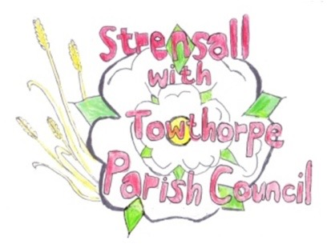
STRENSALL WITH TOWTHORPE PARISH COUNCIL
The Village Hall, Northfields, Strensall, York YO325XW
e-mail: strensalltowthorpePC@outlook.com phone: 01904 491569

MINUTES OF A PLANNING COMMITTEE MEETING HELD ON TUESDAY 25th JANUARY 2022 AT 6.30PM
Councillors Present: Andrew Bolton John Chapman Tony Fisher Ray Maher
In Attendance: Fiona Hill - Parish Clerk
Public Present: 0
- a) To receive apologies for absence given in advance of the meeting: Chris Chambers and Lawrence Mattinson
b) To consider the approval of reasons given for absence: Resolved – Approved (Unanimous)

- To receive any declarations of interest under the Parish Council Code of Conduct or
Members register of interests: None

- To approve the minutes of the monthly Parish Council meeting of 11th January 2022: Resolved – Approved (Unanimous)

- To discuss any ongoing issues and information received:
21/00550/EXTH - 4 York Road – A CYC Planning Enforcement Officer had visited site and no enforcement action will be taken. They advised that the dropped kerb is considered as transport/highway issue and they have been notified.

- To consider and respond to consultations from City of York Council to the following
planning applications:
22/00001/FUL - Two storey side extension, single storey rear extension, 2no. dormers to front, 1no. dormer to rear following demolition of garage and conservatory @ 29 Southfields Road

Resolved – No Objection, but the application includes a full width rear dormer, which is not normally supported in a Conservation Area and this property is in Conservation Area 23 (Unanimous)

22/00019/FUL - Single storey rear extension and replacement fenestration @ The Coach House, Southfields Road

Resolved – Objects, in the strongest terms, as this re-fenestration is totally unacceptable in a Conservation Area and this property is in Conservation Area 23 (Unanimous)

22/00026/FUL - Replacement of cooler plant and erection of 2.4m high enclosure to rear @ Tesco, 40 The Village

Resolved – No Objections (Unanimous)

- To note planning decisions received:
21/02536/FUL - Single storey rear extension @ 27 Park Gate – Approved

21/02537/FUL - Use of existing garage as a dog grooming room (use class E) @ 37 Riverside Walk – Approved

21/02546/FUL - Hip to gable roof extensions to both sides with dormers to front and rear @ Caldie, West End - Approved

21/02584/FUL - Conversion of existing garage into habitable area @ 6 Melcombe Avenue – Approved

21/02685/TCA - Crown reduce and lift 1no. Lime tree in a Conservation Area @ The Vicarage, 10 York Road – Consented

21/99 To confirm date of next meeting as Tuesday 08th February 2022 @ 6.30 p.m. Resolved – Approved (Unanimous)

