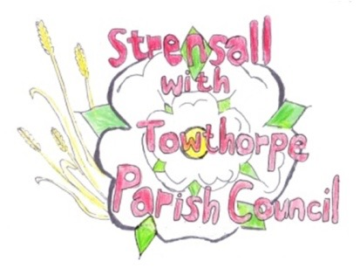
STRENSALL WITH TOWTHORPE PARISH COUNCIL
The Village Hall, Northfields, Strensall, York YO325XW
e-mail: strensalltowthorpePC@outlook.com phone: 01904 491569

NOTICE is hereby given that there will be a Planning Committee meeting of The Parish Council Planning Committee on Tuesday 28th June 2022 at 6.30 pm to be held in the Village Hall for the purpose of transacting the business shown on the Agenda below.
Members of the public and press are welcome to attend
Members of the Council are hereby summoned to attend

AGENDA

1. a) To receive apologies for absence given in advance of the meeting:
b) To consider the approval of reasons given for absence:

2. To receive any declarations of interest under the Parish Council Code of Conduct and Register of Interests

3. To approve the Minutes of 14th June 2022

4. To discuss any ongoing issues and information received:

- Review revised drawings for ‘Caerglow” , Lords Moor Lane

5. To consider and respond to consultations from City of York Council to the planning applications as follows:

- 22/01159/FUL - Proposed single storey rear extension and two storey side extension @ 17 Riverside Walk

6. To note planning decisions received:

- 22/00775/FUL - Erection of single storey summer house/office to rear of garden and erection of storage shed to front garden (part retrospective) @ 37 York Road - Approved
- 22/00824/ADV - Display of 1no. externally illuminated fascia sign, 1no. externally illuminated projecting sign, and 3no. window vinyls @ Tesco, 40 The Village - Refused
- 22/00936/TCA - Crown reduce and lift 1no. Scots Pine tree in a Conservation Area @ 4 West End - Consented

7. To confirm the date of the next meeting: - 12th July 2022 at 6.30pm

Fiona Hill - Clerk to the Parish Council 22nd June 2022

