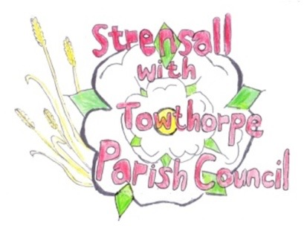**STRENSALL WITH TOWTHORPE PARISH COUNCIL**

The Village Hall, Northfields, Strensall, York YO325XW

e-mail: [strensalltowthorpePC@outlook.com](mailto:strensalltowthorpePC@outlook.com) phone: 01904 491569

**MINUTES OF A PLANNING COMMITTEE MEETING HELD ON TUESDAY 08th MARCH 2022 AT 6.30PM**

**Councillors Present:** Andrew Bolton Chris Chambers Ray Maher Lawrence Mattinson

**In Attendance:** Fiona Hill - Parish Clerk

**Public Present:** 0

1. **a) To receive apologies for absence given in advance of the meeting:**

Parish Councillors John Chapman and Tony Fisher

**b) To consider the approval of reasons given for absence:** Resolved – Approved (Unanimous)

1. **To receive any declarations of interest under the Parish Council Code of Conduct or**

**Members register of interests:** None

1. **To approve the minutes of the monthly Parish Council meeting of 22nd February 2022:** Resolved – Approved (Unanimous)
2. **To discuss any ongoing issues and information received:** None

1. **To consider and respond to consultations from City of York Council to the following**

**planning applications:**

1. 22/00388/FUL – Single storey rear extension following demolition of conservatory @ 63 Barley Rise

Resolved – No Objections (Unanimous)

1. 22/00392/FUL – Single storey side and rear extension @ The Hollies, 48 Moor Lane

Resolved – No Objections (Unanimous)

1. **To note planning decisions received:**
2. 21/02781/FUL – Single storey side and rear extension following demolition of existing conservatory together with re-roofing of existing dwelling @ 4 Ryecroft – Approved
3. 21/02703/FUL - Single storey side and rear extensions, render to front, side and rear @ 12 Wheatcroft - Approved

**21/120 To confirm date of next meeting as Tuesday 22nd March 2022 @ 6.30 p.m.** Resolved – Approved (Unanimous)

**21/121 Exclusion of press and public –** Pursuant to section 1(2) of the Public Bodies (Admission to Meetings) Act 1960, to resolve to exclude the public and press from the remainder of the meeting to protect the confidential nature of the business to be transacted. Resolved – Approved (Unanimous)

**21/122 To discuss any ongoing issues and information received:**

S106 Funding – The Parish Council noted receipt of the two payments, but was disappointed not to receive the final one expected, which had been subject to a long running legal investigation, but the case is now closed.