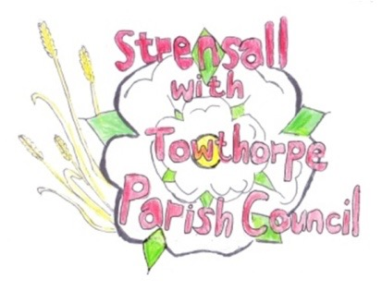
STRENSALL WITH TOWTHORPE PARISH COUNCIL
The Village Hall, Northfields, Strensall, York YO325XW
e-mail: strensalltowthorpePC@outlook.com phone: 01904 491569

MINUTES OF A PLANNING COMMITTEE MEETING HELD ON TUESDAY 10th MAY 2022 AT 6.30PM

Councillors Present: Andrew Bolton Chris Chambers John Chapman Tony Fisher Ray Maher Lawrence Mattinson
In Attendance: Fiona Hill - Parish Clerk
Public Present: 1

- a) To receive apologies for absence given in advance of the meeting: None
b) To consider the approval of reasons given for absence: N/A

- To receive any declarations of interest under the Parish Council Code of Conduct or
Members register of interests: None

- To approve the minutes of the Planning Committee meeting of 26th April 2022: Resolved/Approved (Unanimous)

- To discuss any ongoing issues and information received: - AOD/00101 – The Hawthorns – Discharge of conditions The Parish Council would keep a watching brief on this matter, as these conditions should have been discharged before building commenced.

- To consider and respond to consultations from City of York Council to the following
planning applications: - 22/00761/FUL – Single storey side and rear extensions after demolition of existing conservatory @ 2 Kirklands
Resolved/No Objections (Unanimous)
- 22/00775/FUL – Erection of single storey summer house/office to rear of garden and erection of storage shed to front garden (part retrospective) @ 37 York Road
Resolved/Part Objection, Part No Objections (Unanimous)
The Parish Council does not have any objections to the outbuilding, but objects to the shed in the front garden, as it contravenes the City of York Council Supplementary Planning Document Item 7, it impacts on the street scene and would result in a severe loss of amenity at the property.

- 22/00818/TPO – Crown reduce/prune 3 no. Leylandii trees in a Conservation Area @ 131 The Village
Resolved/No Objection (Unanimous)
The Parish Council had No Objections, in principle, as long as the work is not done during the bird nesting season
- 22/00824/ADV – Display of 1no. externally illuminated fascia sign, 1 no. externally illuminated projecting sign and 3 no. window vinyls @ Tesco, 40 The Village
Resolved/Objection (Unanimous)
The Parish Council Objects, as the vinyls are incongruous within a Conservation Area. All illuminations should be turned off outside opening hours.
- 22/00936/TCA – Crown reduce and lift 1 no. Scots Pine tree in a Conservation Area @ 4 West End
Resolved/No Objection (Unanimous)
The Parish Council has No Objection, subject to approval by the City of York Council Tree Officer.

- To note planning decisions received:
  - 21/02759/FUL – Erection of 1 no. two storey dwelling and 3 no. single storey dwellings (holiday lets) following demolition of house @ Hoxne Farm House, Sheriff Hutton Road – Refused
  - 22/00521/TPO – Fell 1 no. Pine tree protected by Tree Preservation Order no CY230 @ 22 Moor Lane – No Objections

22/14 To confirm date of next meeting as Tuesday 24th May 2022 @ 6.30 p.m. Resolved/Approved (Unanimous)

