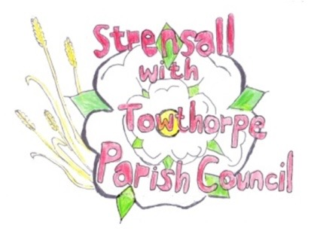
STRENSALL WITH TOWTHORPE PARISH COUNCIL
The Village Hall, Northfields, Strensall, York YO325XW
e-mail: strensalltowthorpePC@outlook.com phone: 01904 491569

MINUTES OF A PLANNING COMMITTEE MEETING HELD ON TUESDAY 12th APRIL 2022 AT 6.30PM

Councillors Present: Andrew Bolton Chris Chambers John Chapman Tony Fisher Ray Maher Lawrence Mattinson
In Attendance: Fiona Hill - Parish Clerk
Public Present: 0

- a) To receive apologies for absence given in advance of the meeting: None
b) To consider the approval of reasons given for absence: N/A

- To receive any declarations of interest under the Parish Council Code of Conduct or
Members register of interests: The Parish Council leased land from City of York Council, which neighbours the land of application 22/00610/FUL.

- To approve the minutes of the monthly Parish Council meeting of 22nd March 2022: Resolved – Approved (Unanimous)

- To discuss any ongoing issues and information received: - 22/00392/FUL -Single storey side and rear extension @ The Hollies 48 Moor Lane Resolved – The Parish Council strongly objects to the felling of a healthy tree, which was not shown on the original planning application, so will be guided by the City of York Council Tree Officer. - 22/00449/FUL - Two storey and single storey side extension following demolition of garage @ 6 Coulson Close Resolved – The revised drawings do not address the Parish Councils original concerns

- To consider and respond to consultations from City of York Council to the following
planning applications:
- 22/00446/FUL – Erection of detached two storey dwelling, alterations to garage and alterations to access (renewal of planning approval 20/00595/FUL) @ Middleton House, 2 Redmayne Square
Resolved – No Objection (Unanimous)
- 22/00610/FUL - First floor rear extension and bifolding doors to rear @ 25 Durlston Drive
Resolved – No Objection, but no builder’s vehicles should be parked over the entrance to the Parish Council leased land
- 22/00700/TPO - Fell 1no. Oak tree protected by Tree Preservation Order no. 131/1989 @ Stoneleigh, 13 Oak Tree Way
Resolved – The Parish Council will accept the recommendation of the City of York Council Tree Office. If it is determined that the tree should be felled, the Parish Council would ask that a replacement English Oak is planted.

- To note planning decisions received:
- 21/00944/FUL - Conversion of garage into habitable space (part retrospective) @ 15 The Village – Approved
- 21/02714/FUL - Removal of existing conservatory, erection of glazed canopy and installation of 2no. French doors to rear, relocation of garage doors to front @ Middleton House, 2 Redmayne Square – Approved
- 21/02716/FUL - Erection of 1no. 2 storey dwelling (resubmission of 16/01199/FUL with design alterations) @ Middleton House, 2 Redmayne Square – Approved
- 21/02803/FUL - First floor side and rear extension @ 9 Princess Road – Approved
- 22/00019/FUL - Single storey rear extension and replacement fenestration @ The Coach House Southfields Road – Approved
- 22/00052/FUL - Variation of condition 4 of permitted application 04/02460/FUL to alter opening hours from 0700 - 2100 hrs to 0700 - 2200 hrs @ Strensall Camp Service Station 605 Strensall Road – Approved
- 22/00187/FUL – Single storey side and rear extension @ 12 Moorland Garth – Approved
- 22/00319/TCA - Fell 1no. Norway Spruce; crown lift 1no. Himalayan Birch - tree works in a Conservation Area @ 18 The Village - Consented

22/7 To confirm date of next meeting as Tuesday 26th April 2022 @ 6.30 p.m. Resolved – Approved (Unanimous)

