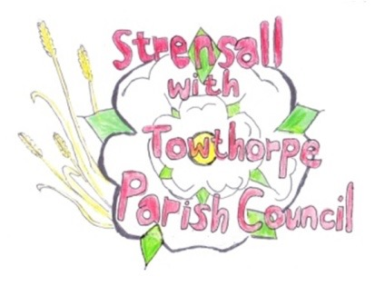
STRENSALL WITH TOWTHORPE PARISH COUNCIL
The Village Hall, Northfields, Strensall, York YO325XW
e-mail: strensalltowthorpePC@outlook.com phone: 01904 491569

MINUTES OF A PLANNING COMMITTEE MEETING HELD ON TUESDAY 14th JUNE 2022 AT 6.30PM
Councillors Present: Andrew Bolton Chris Chambers John Chapman Tony Fisher Ray Maher Lawrence Mattinson
In Attendance: Fiona Hill - Parish Clerk
Public Present: 0
- a) To receive apologies for absence given in advance of the meeting: None
b) To consider the approval of reasons given for absence: N/A

- To receive any declarations of interest under the Parish Council Code of Conduct or
Members register of interests: None

- To approve the minutes of the Planning Committee meeting of 24th May 2022: Resolved/Approved (Unanimous)

- To discuss any ongoing issues and information received: The committee briefly spoke about the Addlington Homes (former military housing) which
were now for sale, as they were no longer required by the MOD.

- To consider and respond to consultations from City of York Council to the following
planning applications: 22/01032/FUL - Change of use of agricultural land to the siting of 118 storage containers (use class B8) – retrospective @ BHE Self Storage, Lambshill, Towthorpe Moor Lane
Resolved – Objection (five votes in favour of resolution to object, one vote against)
The Parish Council objects, as this is inappropriate development in the greenbelt, which affects the openness of the greenbelt and there are no special circumstances to justify exemption (NPPF149)

- To note planning decisions received: a) 22/00446/FUL - Erection of detached two storey dwelling, alterations to garage and alterations to access (renewal of planning approval 20/00595/FUL) @ Middleton
House, 2 Redmayne Square – Approved
- 22/00700/TPO - Fell 1no. Oak tree protected by Tree Preservation Order no. 131/1989 @ Stoneleigh, 13 Oak Tree Way – No Objections
- 22/00761/FUL - Single storey side and rear extensions after demolition of existing
conservatory @ 2 Kirklands – Approved
- 22/00818/TPO - Crown reduce/prune 3no. Leylandii trees in a Conservation Area @ 131 The Village - Consented

22/29 To confirm date of next meeting as Tuesday 28th June 2022 @ 6.30 p.m. Resolved/Approved (Unanimous)

