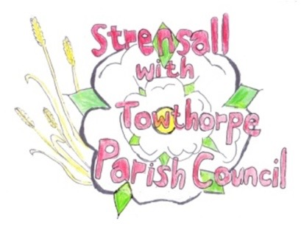
STRENSALL WITH TOWTHORPE PARISH COUNCIL
The Village Hall, Northfields, Strensall, York YO325XW
e-mail: strensalltowthorpePC@outlook.com phone: 01904 491569

MINUTES OF A PLANNING COMMITTEE MEETING HELD ON TUESDAY 24th MAY 2022 AT 6.30PM
Councillors Present: Andrew Bolton John Chapman Tony Fisher Ray Maher Lawrence Mattinson
In Attendance: Fiona Hill - Parish Clerk
Public Present: 0
- a) To receive apologies for absence given in advance of the meeting: Chris Chambers
b) To consider the approval of reasons given for absence: Resolved/Approved (Unanimous)

- To receive any declarations of interest under the Parish Council Code of Conduct or
Members register of interests: None

- To approve the minutes of the Planning Committee meeting of 10th May 2022: Resolved/Approved (Unanimous)

- To discuss any ongoing issues and information received: None

- To consider and respond to consultations from City of York Council to the following
planning applications: None

- To consider and respond to planning application with Ryedale District Council as follows:
21/01219/FUL - Formation of 2no hardstanding touring pitches and 2no grass touring pitches, change of use of part of existing shower block as amenity building for drinking establishment (cafe and bar) for camp site users, together with section of associated outdoor space for use in conjunction with the drinking establishment and retention of the buildings timber single storey extension for storage use (retrospective application) @ Flaxton Meadows, York Lane, Flaxton
Resolved/Objection (Unanimous)
Due to insufficient information from the applicant about the impact the additional development will have on the SSSI “Strensall Common”, which is in close proximity to the site. Concerns raised by Natural England and the Habitats Regulations Assessment of the City of York Council, should be addressed.
It is noted in the Dragonfly Environmental Consulting Ltd Noise management Plan that they state Strensall Common is an area managed by the Wildfowl and Wetland Trust. This is incorrect. It is managed primarily by Landmark DIO and in part by York Wildlife Trust, overseen by Natural England

- To note planning decisions received:
- 22/00610/FUL - First floor rear extension and bifolding doors to rear @ 25 Durlston Drive – Approved
- 22/00449/FUL - Two storey and single storey side extension following demolition of garage @ 6 Coulson Close - Approved

22/22 To confirm date of next meeting as Tuesday 14th June 2022 @ 6.30 p.m. Resolved/Approved (Unanimous)

