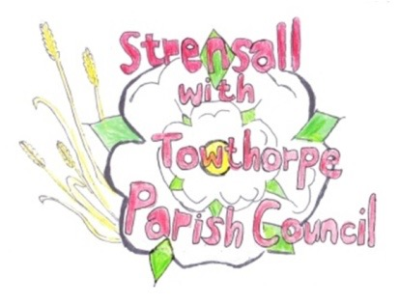
STRENSALL WITH TOWTHORPE PARISH COUNCIL
The Village Hall, Northfields, Strensall, York YO325XW
e-mail: strensalltowthorpePC@outlook.com phone: 01904 491569

MINUTES OF A PLANNING COMMITTEE MEETING HELD ON TUESDAY 26th APRIL 2022 AT 6.30PM
Councillors Present: Andrew Bolton Chris Chambers John Chapman Tony Fisher Ray Maher
In Attendance: Fiona Hill - Parish Clerk
Public Present: 1 – Parish Councillor James Dickson
Richard Holland, Senior Transport Projects Manager, City of York Council spoke to the Parish Council about the Public Consultation for the Haxby Station Project
- a) To receive apologies for absence given in advance of the meeting: Lawrence Mattinson
b) To consider the approval of reasons given for absence: Resolved/Approved (Unanimous)

- To receive any declarations of interest under the Parish Council Code of Conduct or
Members register of interests: None

- To approve the minutes of the Planning Committee meeting of 12th April 2022: Resolved/Approved (Unanimous)

- To discuss any ongoing issues and information received: None

- To consider and respond to consultations from City of York Council to the following
planning applications: - 22/00733/TCA - Fell 1no. Acer; crown reduce 1no. Sycamore by 30% - tree works in a Conservation Area @ The Farmhouse 66 The Village
Resolved/Objection (Unanimous)
The Parish Council is unhappy about the potential loss of a tree within the Conservation and extensive work on what appears to be a healthy tree. The Parish Council will defer to the City of York Council Tree Officer.

- To note planning decisions received:
  - 22/00001/FUL - Two storey side extension, single storey rear extension, 2no. dormers to front, 1no. dormer to rear following demolition of garage and conservatory @ 29 Southfields Road – Approved
  - 22/00388/FUL - Single storey rear extension following demolition of conservatory @ 63 Barley Rise - Approved

22/14 To confirm date of next meeting as Tuesday 10th May 2022 @ 6.30 p.m. Resolved/Approved (Unanimous)

