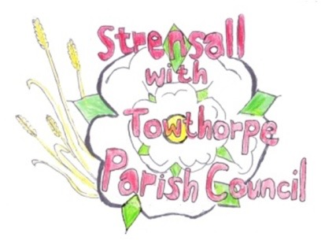
STRENSALL WITH TOWTHORPE PARISH COUNCIL
The Village Hall, Northfields, Strensall, York YO325XW

e-mail: strensalltowthorpePC@outlook.com phone: 01904 491569

MINUTES OF A TREES, ALLOTMENTS & OPEN SPACES COMMITTEE MEETING HELD ON TUESDAY 25th JANUARY 2022 AT 7.15PM

Councillors Present: John Chapman Tony Fisher
In Attendance: Fiona Hill - Parish Clerk
Parish Councillors Ray Maher and Sue Nunn
Public Present: 0
The Terms Of Reference state that a quorum is not less than 50% of the membership, which is currently four, so with two members, the meeting could commence.
Parish Councillors Ray Maher and Sue Nunn were invited to join this committee and duly accepted.
- a) To elect a Chairman until the Annual Parish Council Meeting 2022:
Resolved – John Chapman (Unanimous)
b) To elect a Vice-Chairman until the Annual Parish Council Meeting 2022:
Resolved – Tony Fisher (Unanimous)

- a) To receive apologies for absence given in advance of the meeting: Chris Chambers and Kevin Ogilvy
b) To consider the approval of reasons given for absence: Resolved – Approved (Unanimous)

- To receive any declarations of interest under the Parish Council Code of Conduct or
Members register of interests: None

- To approve the minutes of the committee meeting of Tuesday 14th September 2021:
Resolved – Approved (Unanimous)

- To discuss issues regarding Trees:
- Year One – All work done, except for one felled tree, on West Pit Lane, which needed cutting up. Cllr Chapman had spoken to Tim Preston, who had promised to visit ASAP.

- Year Two – The Parish Council would request quotes from Tim Preston, Lewis Trees, Bartlett Trees and would post details on Facebook.

- Queen 70th Anniversary Tree – Cllr Chapman had met with Women’s Institute committee members at the planting site and Cllr Fisher had spoke to them at a later stage. The committee had emailed to say they had decided on an English Oaks and would obtain quotes for supply and planting.
Resolved – The Parish Council would obtain a quote for grinding the stump at the site of the felled tree (Unanimous)

- Hallard Way:
Resolved – The Parish Council would ask Tim Preston to remove the self-seeded trees (Alders?), growing near the fence and remove the arisings.

- York Road Open Space:
Resolved – The Parish Council would ask Tim Preston to remove the Ash Tree, which has Die Back, remove arisings and replace it with a pink flowering cherry blossom.

- Northfield Play Park:
Resolved - The Parish Council would ask Tim Preston to remove the cages from the two trees either side of the stump.

- To discuss issues regarding Allotments:
- Rents 2022 - All paid

- To discuss issues regarding Open Spaces: - Moor Lane/Lords Moor Lane Footpath – The Parish Council are delighted with the work
done by Atkinson & Son and had received lots of positive feedback.

- Durlston Drive road/drainage works – The Parish Council are delighted with the work done by York Landscapes and had received lots of positive feedback. The Parish Council had written to City of York Council discouraging them from using the area as a turning circle.

- The Mews/Moor Lane – Drainage/Flooding concerns – Cllr Fisher would speak to Brian Hebditch of City of York Council to seek advice.

- Wild Flowering – Update – Cllr Fisher would seek advice from Yorkshire Wildlife Trust. The Tony Fisher Environment Fund would pay for the seed.
Resolved – Wild Flowering could be done on Leyfield Close and other areas would be considered in the future (Unanimous)
Resolved – The cost of one days hire of a scarifier was agreed (Unanimous)

- Volunteering – Cllr Fisher reported that he had a list of those who had expressed an interest in helping with parish projects.

- Tree Planting – Cllr Fisher would meet with Steve Popple and visit the Open Area, with a view to finding suitable site for trees. The Parish Council asked that a written report would be submitted, showing exact locations, suggested species etc, which could be considered by the Parish Council.

21/13 To confirm date of the next meeting as Tuesday 22nd March 2022 at 7.15 p.m.: Resolved – Approved (Unanimous)

