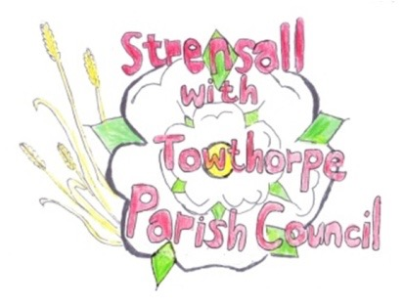
STRENSALL WITH TOWTHORPE PARISH COUNCIL

The Village Hall, Northfields, Strensall, York YO325XW
e-mail: strensalltowthorpePC@outlook.com
phone: 01904 491569
Chairman : Mr A H Fisher

MINUTES OF AN PARISH COUNCIL MEETING HELD IN THE VILLAGE HALL ON THURSDAY 11th OCTOBER 2022 AT 7.15 PM
Councillors Present: Andrew Bolton Chris Chambers Tony Fisher* Lawrence Mattinson Susan Nunn Kevin Ogilvy
In Attendance: Fiona Hill - Parish Clerk

Public Present: 5
** City of York Councillor
- a) To receive apologies for absence given in advance of the meeting: Parish Councillor John Chapman* City of York Councillor Paul Doughty
b) To consider the approval of reasons given for absence: *Resolved/Approved (Unanimous)

- To discuss the ordinary and casual vacancies: NTR

- To receive any declarations of interest under the Parish Council Code of Conduct or
Members register of interests: Cllr Chambers – Community Events Team Grant Application – Committee Member

- a) To approve the minutes of the Parish Council meeting of 13th September 2022:
Resolved – Approved, subject to an amendment to the Ward Cllrs section (Unanimous)
b) To endorse the approved Planning Committee minutes of 13th and 27th September 2022:
Resolved – Endorsed (Unanimous)

- Public participation on any subject relating to the agenda: Residents from the Vale of York Residential Park on Sheriff Hutton Road asked what traffic calming measures could be put in place to assist them when trying to get to the village. Cllr Fisher advised that this was not a Parish Council issue, but he would, on their behalf, raise this with City of York Council.

22/50 To receive matters raised by/with City of York Ward Councillors: Cllr Fisher reported that the planning applications had been submitted for the York Outer Ring Road A64/A19 and Haxby Railway Station.
22/51 To discuss and, if necessary, agree action on matters arising/ongoing issues: a) North Yorkshire Police monthly reports - No report received b) Yorkshire Water - allotment water supply Cllr Chambers had obtained quoted from both Yorkshire Water and a contractor and the cost was several thousand pounds, so was financially beyond the reach of allotment holders and the Parish Council, so no further action would be taken.
Cllr Nunn thanked the scouts and cubs for bulb planting along York Road.
22/52 To discuss and, if necessary, agree action on matters raised since last meeting: a) Strensall Community Events Team – Christmas Together – Grant Application Resolved – The Parish Council agreed to pay a grant of £850.00 (Unanimous)
22/53 To discuss and, if necessary, agree action, on any correspondence received: a) City of York Council – Proposed introduction of 30mph Speed Limit – Towthorpe Road (C92) – The Parish Council fully supported this scheme.
22/54 To discuss matters raised by/with Responsible Financial Officer (RFO): a) Bank reconciliation, income received, payments made to date The Parish Clerk had circulated a bookkeeping spreadsheet by email, with bank accounts totalling £210035.64 b) Internal controls checks – This will be done as part of the interim audit on Friday 14 October 2022 c) Yorkshire Local Councils Association – NTR
22/55 To confirm the date of the next meeting as Tuesday 08th November 2022 at 7.15 p.m.: Resolved – Approved (Unanimous)

