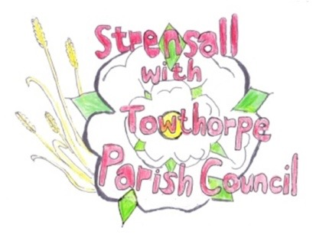
STRENSALL WITH TOWTHORPE PARISH COUNCIL
The Village Hall, Northfields, Strensall, York YO325XW
e-mail: strensalltowthorpePC@outlook.com phone: 01904 491569

MINUTES OF A PLANNING COMMITTEE MEETING HELD ON TUESDAY 08th NOVEMBER 2022 AT 6.30PM
Councillors Present: Andrew Bolton Chris Chambers Tony Fisher* Lawrence Mattinson
In Attendance: Fiona Hill - Parish Clerk
Public Present: 3
* City of York Councillor
- a) To receive apologies for absence given in advance of the meeting: Parish Councillor John Chapman
b) To consider the approval of reasons given for absence: Resolved/Approved (Unanimous)

- To receive any declarations of interest under the Parish Council Code of Conduct or
Members register of interests: None

- To approve the minutes of the Planning Committee meeting of 25th October 2022: Resolved/Approved (Unanimous)

22/94 To discuss any ongoing issues and information received: - 12 The Village – dialogue is ongoing between CYC and the architect
22/95 To consider and respond to consultations from City of York Council to the following planning applications: - 22/01843/FUL - Erection of outbuilding to side elevation @ 34 Kirklands Resolved/Objection, The Parish Council feel it is unacceptable to build in the front garden, which affects the street scene and contravenes the Neighbourhood Plan. - 22/01945/FUL - Erection of oak framed open fronted garage to front elevation @ 521 Strensall Road Resolved/Neutral, No Objections, however the Parish Council is concerned about building in front of a property within the Green Belt (Unanimous) - 22/02019/FUL - Single storey rear extension @ 111 The Village Resolved/Neutral, No Objections (Unanimous) - 22/02207/FUL - Dormer to rear @ 106 The Village Resolved/Neutral, No Objections (Unanimous) - 22/02236/TCA - Fell 1no. Ash tree in a Conservation Area @ 130 The Village Resolved/Neutral, The Parish Council will be guided by the CYC Tree Officer (Unanimous)
22/96 To note planning decisions received:
- 22/02036/TCA – Various tree works including the felling of 1no. Conifer tree in a Conservation Area @ 69 The Village – Consented

22/97 To confirm date of next meeting at Tuesday 22nd November 2022 @ 6.30 p.m.
Resolved/Approved (Unanimous)

