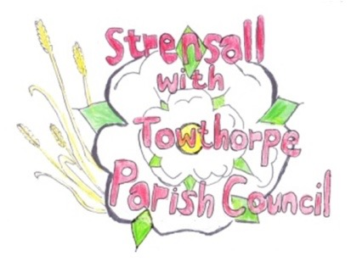
STRENSALL WITH TOWTHORPE PARISH COUNCIL
The Village Hall, Northfields, Strensall, York YO325XW
e-mail: strensalltowthorpePC@outlook.com phone: 01904 491569

MINUTES OF A PLANNING COMMITTEE MEETING HELD ON TUESDAY 09th AUGUST 2022 AT 6.45PM
Councillors Present: Andrew Bolton Chris Chambers John Chapman Lawrence Mattison
In Attendance: Fiona Hill - Parish Clerk
Public Present: 0
* City of York Councillor
- a) To receive apologies for absence given in advance of the meeting: Parish Councillor Tony Fisher*^
Paul Doughty*
b) To consider the approval of reasons given for absence: ^Resolved/Approved (Unanimous)

- To receive any declarations of interest under the Parish Council Code of Conduct or
Members register of interests: None

- To approve the minutes of the Planning Committee meeting of 26th July 2022: Resolved/Approved (Unanimous)

22/52 To discuss any ongoing issues and information received: None

22/53 To consider and respond to consultations from City of York Council to the following planning applications: - 22/01489/FUL – Loft conversion including 6no. roof lights to ear, 2no. roof lights to frontand 2no. new window openings to side @ Bonneycroft Resolved/Objection (3 votes in favour of motion and 1 vote against) “The cabriolet balcony velux windows, which are tantamount to an external balcony, cause damage to amenity of neighbours property due to overlooking, in particular “watch tower” effect”
22/54 To note planning decisions received: - 22/00464/FUL – Raising of ridge height to facilitate loft conversion and partial rendering of external elevations, erection of gates to front access @ Caerglow, Lords Moor Lane - Approved

22/55 To confirm date of next meeting at Tuesday 23th August 2022 @ 6.30 p.m.
Resolved/Approved (Unanimous)

