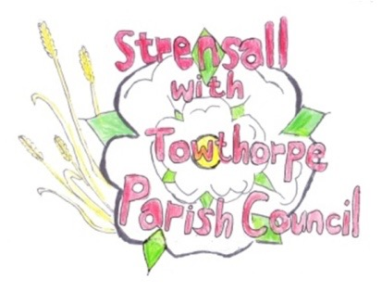
STRENSALL WITH TOWTHORPE PARISH COUNCIL
The Village Hall, Northfields, Strensall, York YO325XW
e-mail: strensalltowthorpePC@outlook.com phone: 01904 491569

MINUTES OF A PLANNING COMMITTEE MEETING HELD ON TUESDAY 11th OCTOBER 2022 AT 6.30PM
Councillors Present: Andrew Bolton Chris Chambers Tony Fisher* Lawrence Mattinson
In Attendance: Fiona Hill - Parish Clerk
Public Present: 0
* City of York Councillor
- a) To receive apologies for absence given in advance of the meeting: Parish Councillor John Chapman
b) To consider the approval of reasons given for absence: Resolved/Approved (Unanimous)

- To receive any declarations of interest under the Parish Council Code of Conduct or
Members register of interests: None

- To approve the minutes of the Planning Committee meeting of 27th September 2022: Resolved/Approved (Unanimous)

22/80 To discuss any ongoing issues and information received: NTR
22/81 To consider and respond to consultations from City of York Council to the following planning applications: a) 22/02036/TCA - Various tree works including the felling of 1no. Conifer tree in a Conservation Area @ 69 The Village Resolved/No Objection (Unanimous) – provided the work is done by a qualified tree surgeon, subject to the approval of the City of York Trees Officer b) 22/02015/FUL - Single storey rear extension following demolition of existing conservatory @ 7 Duncombe Drive Resolved/No Objection (Unanimous)
22/82 To note planning decisions received:
a) 22/01081/FUL - Demolition of existing attached single garage. Erection of two storey extension consisting of a single garage with utility room and WC to the rear, with bedroom and ensuite shower room over @ 4 West End – Approved
- 22/01667/FUL - Extension to side with 1no. dormer to front and 1no. dormer to rear, single storey front and rear extension demolition of existing garage @ 30 Pasture Close - Approved

22/83 To confirm date of next meeting at Tuesday 25th October 2022 @ 6.30 p.m.
Resolved/Approved (Unanimous)

