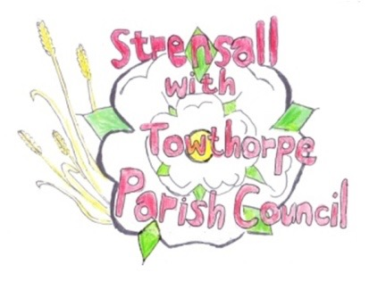
STRENSALL WITH TOWTHORPE PARISH COUNCIL
The Village Hall, Northfields, Strensall, York YO325XW
e-mail: strensalltowthorpePC@outlook.com phone: 01904 491569

MINUTES OF A PLANNING COMMITTEE MEETING HELD ON TUESDAY 13th SEPTEMBER 2022 AT 6.30PM

Councillors Present: Andrew Bolton Chris Chambers John Chapman Tony Fisher* Lawrence Mattinson
In Attendance: Fiona Hill - Parish Clerk
Public Present: 2
* City of York Councillor

Chairman – “Strensall with Towthorpe Parish Council is deeply saddened at the death of Her Majesty Queen Elizabeth II and send our heartfelt condolences and prayers to the Royal family at this very sad time. We will now observe a minutes silence”.

- a) To receive apologies for absence given in advance of the meeting: None
b) To consider the approval of reasons given for absence: N/A

- To receive any declarations of interest under the Parish Council Code of Conduct or
Members register of interests: 22/01669/FUL – Parish Councillor Tony Fisher, who had spoken to the applicant, would take no part in the discussion, other than to comment on planning procedure.

- To approve the minutes of the Planning Committee meeting of 23rd August 2022: Resolved/Approved (Unanimous)

22/66 To discuss any ongoing issues and information received: a) 21/02757/OUT - Outline application for the demolition of existing structures and erection of 6no. dwellings with associated access, car parking and landscaping (with all matters reserved except for access, layout and scale) @ Pigotts Autoparts, Sheriff Hutton Road – Amended description/revised plans
Resolved – The Parish Council would submit a response to City of York Council as follows: “The Parish Council wishes to repeat its objection to this inappropriate and unsustainable development within the Greenbelt” (Proposed: Cllr Bolton, Seconded: Cllr Chapman, 3 votes in favour of resolution, 1 vote against the resolution and 1 abstention)

22/67 To consider and respond to consultations from City of York Council to the following planning applications:
- 22/01669/FUL - Erection of detached dwelling to side/west of 12 The
Village (resubmission) @ The Sycamores, 12 The Village
Resolved – The Parish Council would submit a response to City of York Council as follows: “The Parish Council wishes to Object, for the reasons as follows:
- The use of zinc cladding to front elevation of building is inappropriate in the Conservation Area.
- The contemporary oriel window is not in keeping with the Conservation Area.
- The scale and mass of building is inappropriate in the Conservation Area.
- There appears to be a protruding balcony surrounded by a balustrade to rear of property. This would cause harm to privacy of neighbours property. The Parish Council wishes to refer you to application 22/00116/FUL and the reasons for refusal. (Proposed: Cllr Bolton, Seconded: Cllr Chambers, Cllrs votes unanimously in favour of resolution)

- 22/01805/FUL - Single storey rear extension @ 3 Langton Court
Resolved – The Parish Council would submit a response to City of York Council as follows: “The Parish Council has No Objection”, (Proposed: Cllr Bolton, Seconded: Cllr Chapman, Unanimous)
22/68 To note planning decisions received:

a) 22/01359/FUL - Single storey side extension @ 6 Coulson Close – Approved

- 22/01243/FUL - Siting of storage container for safe storage of sports pitch maintenance equipment and materials @ Strensall And Towthorpe Sports Association Sports Ground, Durlston Drive – Approved

22/69 To confirm date of next meeting at Tuesday 27th September 2022 @ 6.30 p.m.
Resolved/Approved (Unanimous)

