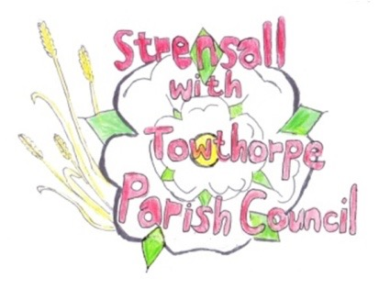
STRENSALL WITH TOWTHORPE PARISH COUNCIL
The Village Hall, Northfields, Strensall, York YO325XW
e-mail: strensalltowthorpePC@outlook.com phone: 01904 491569

MINUTES OF A PLANNING COMMITTEE MEETING HELD ON TUESDAY 22nd NOVEMBER 2022 AT 6.30PM

Councillors Present: Andrew Bolton Chris Chambers Tony Fisher* John Chapman
In Attendance: Fiona Hill - Parish Clerk
Public Present: 0
* City of York Councillor
The Chairman welcomed Cllr Chapman back and wished him a speedy recovery

- a) To receive apologies for absence given in advance of the meeting: None
b) To consider the approval of reasons given for absence: N/A

- To receive any declarations of interest under the Parish Council Code of Conduct or
Members register of interests: None

- To approve the minutes of the Planning Committee meeting of 08th November 2022: Resolved/Approved (Unanimous)

22/101 To discuss any ongoing issues and information received: Hawthorns – Cllr Bolton was contacted by a resident who was concerned about the flue currently being fitted as they did not recall seeing a flue coming out of the side of the house on approved drawings. He advised that whilst the flue position was not exactly to the approved drawing, the change from drawing was not really material and providing the flue was fitted according to HETAS and building regulations there should not be any harm caused.
The resident also complained about the approved internal garage, now being fully glazed with transparent glass and was now a room. Cllr Bolton believed that City of York Council were already aware of this.
22/102 To consider and respond to consultations from City of York Council to the following planning applications: - 22/02358/TCA - Reduce height by 2 metres of 1no. Yew and shape; reduce height by 3 metres of 1no. Holly; remove 2no. stems from 1no. Conifer - tree works in a Conservation Area @ The Grange, 59 The Village
Resolved / No Objection (Unanimous) Subject to approval by the City of York Council Tree Officer and the work being carried out by a qualified tree surgeon. The Parish Council would remind City of York Council that the property is a Grade Two listed building, adjacent to the War Memorial and within the Conservation Area.

22/103 To note planning decisions received:
- 22/00058/FUL - Internal and external alterations to existing detached building serving office, residential accommodation and garage range @ Manor Farm 1 The Village - Approved
- 22/00059/LBC - Internal and external alterations to include conversion of former garage into day room, new door and window openings, remove doors and install timber bi-fold doors in former barn and convert into garage, replace septic tank with package treatment plant, alter and install new timber windows and door to replace existing uPVC units, re-roof outbuilding, various repairs, form new staircase to roof void for storage and convert front bedroom into bathroom @ Manor Farm 1 The Village - Approved
- 22/01500/TCA - Fell 2no. Sycamore trees; pollard 1no. Lime tree to 2.4m - tree works in a Conservation Area @ The Gables, 2 Church Lane - Consented

22/104 To confirm date of next meeting at Tuesday 13th December 2022 @ 6.30 p.m.
Resolved/Approved (Unanimous)

