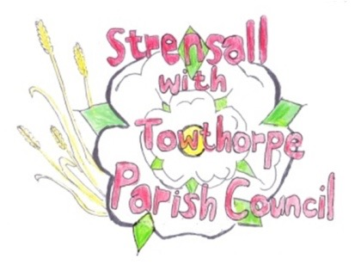
STRENSALL WITH TOWTHORPE PARISH COUNCIL
The Village Hall, Northfields, Strensall, York YO325XW
e-mail: strensalltowthorpePC@outlook.com phone: 01904 491569

MINUTES OF A PLANNING COMMITTEE MEETING HELD ON TUESDAY 23rd AUGUST 2022 AT 6.30PM
Councillors Present: Chris Chambers John Chapman Tony Fisher* Lawrence Mattinson
In Attendance: Fiona Hill - Parish Clerk
Public Present: 0
* City of York Councillor
- a) To receive apologies for absence given in advance of the meeting: Parish Councillor Andrew Bolton
b) To consider the approval of reasons given for absence: Resolved/Approved (Unanimous)

- To receive any declarations of interest under the Parish Council Code of Conduct or
Members register of interests: 22/01752/TCA – Parish Councillor Lawrence Mattinson

- To approve the minutes of the Planning Committee meeting of 09th August 2022: Resolved/Approved (Unanimous)

22/59 To discuss any ongoing issues and information received: Alterations have been made to a double garage at 1 Princess Road, in Conservation Area 23, (17/00198). One garage door has been replaced by a window. Possible change of use, but should be notified to enforcement.
14, Oakhill Crescent is being advertised as an Airbnb and a party house. May need to go to enforcement as unauthorised change of use. There are also noise issues.
22/60 To consider and respond to consultations from City of York Council to the following planning applications: a) 22/01212/FUL - Single storey rear extension following removal of existing conservatory @ 16 Chatsworth Avenue Resolved/No Objections (Unanimous) b) 22/01667/FUL - Extension to side with 1no. dormer to front and 1no. dormer to rear, single storey front and rear extension demolition of existing garage @ 30 Pasture Close Resolved/No Objections (Unanimous) c) 22/01308/FUL - Single storey side and rear extension @ Holme Lodge 1 Holme Lea Resolved/No Objections (Unanimous) d) 22/01752/TCA - Lateral crown prune 1no. Copper Beech tree in a Conservation Area @ The Poplars, Princess Road Resolved/No Objections, the Parish Council will be guided by the CYC Tree Officer (Unanimous)
22/61 To note planning decisions received:
- 21/02743/FUL - Installation of a modular self-service launderette facility and associated works (retrospective) @ Strensall Camp Service Station, 605 Strensall Road - Approved
- 22/00116/FUL - Single storey rear and side extension, change window colour throughout @ 6 The Village – Refused

22/62 To confirm date of next meeting at Tuesday 13th September 2022 @ 6.30 p.m.
Resolved/Approved (Unanimous)

