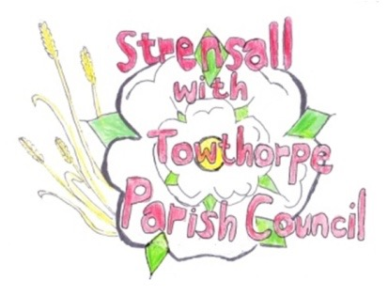
STRENSALL WITH TOWTHORPE PARISH COUNCIL
The Village Hall, Northfields, Strensall, York YO325XW
e-mail: strensalltowthorpePC@outlook.com phone: 01904 491569

MINUTES OF A PLANNING COMMITTEE MEETING HELD ON TUESDAY 25th OCTOBER 2022 AT 6.30PM
Councillors Present: Chris Chambers Tony Fisher* Lawrence Mattinson
In Attendance: Fiona Hill - Parish Clerk
Public Present: 0
* City of York Councillor
- a) To receive apologies for absence given in advance of the meeting: Parish Councillors John Chapman and Andrew Bolton
b) To consider the approval of reasons given for absence: Resolved/Approved (Unanimous)

- To receive any declarations of interest under the Parish Council Code of Conduct or
Members register of interests: None

- To approve the minutes of the Planning Committee meeting of 11th October 2022: Resolved/Approved (Unanimous)

22/80 To discuss any ongoing issues and information received: NTR
22/81 To consider and respond to consultations from City of York Council to the following planning applications: a) 22/00945/FUL - Render to front, replacement roof and replacement windows @ 26 Riverside Walk Resolved/Neutral, No Objection (Unanimous) b) 22/02095/FUL - Single storey side extension @ Montana, 18 York Road Resolved/Neutral, No Objection – subject to footprint not being within the root zone of any trees (Unanimous) c) 22/02084/FUL - Single storey rear extension following demolition of existing conservatory @ Rowan House 14 Redmayne Square Resolved/Neutral, No Objection (Unanimous) d) 22/01184/FUL - Replacement fence to the rear and sides of war memorial @ War Memorial, The Village The Parish Council, as the applicant, felt should not comment
22/82 To note planning decisions received:
- 22/01308/FUL - Single storey side and rear extension @ Holme Lodge 1 Holme Lea – Approved
- 22/01749/CPD - Certificate of lawfulness for proposed loft conversion @ 3 Fossview Close @ Refused

22/83 To confirm date of next meeting at Tuesday 08th November 2022 @ 6.30 p.m.
Resolved/Approved (Unanimous)

