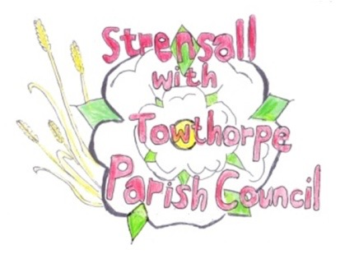
STRENSALL WITH TOWTHORPE PARISH COUNCIL
The Village Hall, Northfields, Strensall, York YO325XW
e-mail: strensalltowthorpePC@outlook.com phone: 01904 491569

MINUTES OF A PLANNING COMMITTEE MEETING HELD ON TUESDAY 26th JULY 2022 AT 6.30PM
Councillors Present: Andrew Bolton Chris Chambers John Chapman Tony Fisher
In Attendance: Fiona Hill - Parish Clerk
Public Present: 0
- a) To receive apologies for absence given in advance of the meeting: Parish Councillors and Lawrence Mattison
b) To consider the approval of reasons given for absence: Resolved/Approved (Unanimous)

- To receive any declarations of interest under the Parish Council Code of Conduct or
Members register of interests:
Cllr Fisher – withdrew from the meeting for the duration of the discussion regarding application 22/01032/FUL

- To approve the minutes of the Planning Committee meeting of 12th July 2022: Resolved/Approved (Unanimous)

22/47 To discuss any ongoing issues and information received: - Hawthorns – Cllr Fisher reported that CYC Planning Dept had advised that the sign was within the permitted size. The Parish Council discussed other planning issues. - 22/01032/FUL – The Parish Council noted that CYC Ward Cllr Paul Doughty has called in this application, requesting that the applicant was given more time to demonstrate what special circumstance applied to justify development within the greenbelt. Resolved – Approved (Unanimous) – The Parish Council would submit a further response as follows – “In light of the decision to refuse 22/00939/FUL dated 21 July 2022 for thirty- eight containers and the reason for refusal - their impact on the green belt. The Parish Council believes that the Lambshill application should be refused for very similar reasons”

22/48 To consider and respond to consultations from City of York Council to the following planning applications: - 22/01359/FUL – Single storey side extension @ 6 Coulson Close Resolved/Objection (Unanimous) “If this application is instead of the approved application (Ref No TBC), then the Parish Council has No Objections, however, if this application is in addition to the approved application (Ref No TBC), then this is over-development of the site and the Parish Council Objects

- 22/01500/TCA – Fell 2no. Sycamore trees; pollard 1no. Lime tree to 2.4m – tree works in a Conservation Area @ The Gables, 2 Church Lane
Resolved/Objection (Unanimous)
“The Parish Council requests the applicant provides the tree works and map as indicated on the application form, as there is currently insufficient information to make an informed decision. The Parish Council would suggest the City of York Council Tree Officer will need the same information”.

- To note planning decisions received: None

- To confirm date of next meeting at Tuesday 09th August 2022 @ 6.30 p.m.
Resolved/Approved (Unanimous)

