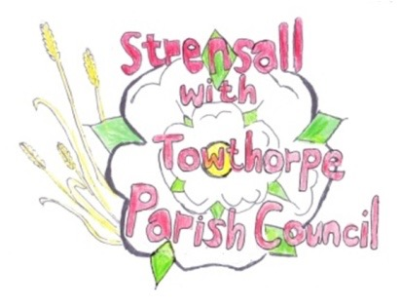
STRENSALL WITH TOWTHORPE PARISH COUNCIL
The Village Hall, Northfields, Strensall, York YO325XW
e-mail: strensalltowthorpePC@outlook.com phone: 01904 491569

MINUTES OF A PLANNING COMMITTEE MEETING HELD ON TUESDAY 27th SEPTEMBER 2022 AT 6.30PM

Councillors Present: Andrew Bolton Tony Fisher* Lawrence Mattinson
In Attendance: Fiona Hill - Parish Clerk
Public Present: 1 – Keith Marquis, Chairman, Neighbourhood Planning Working Group
* City of York Councillor

- a) To receive apologies for absence given in advance of the meeting: Parish Councillors Chris Chambers and John Chapman
b) To consider the approval of reasons given for absence: Resolved/Approved (Unanimous)

- To receive any declarations of interest under the Parish Council Code of Conduct or
Members register of interests: None

- To approve the minutes of the Planning Committee meeting of 13th September 2022: Resolved/Approved (Unanimous)

22/73 To discuss any ongoing issues and information received: Neighbourhood Planning – The committee partially reviewed the examiners report and agreed it was not able to approve it, as it should be dealt with by the whole Parish Council.
22/74 To consider and respond to consultations from City of York Council to the following planning applications: None
22/75 To note planning decisions received:
a) 22/01212/FUL - Single storey rear extension following removal of existing conservatory @ 16 Chatsworth Avenue – Approved
- 22/01489/FUL - Loft conversion including 6no. roof lights to rear, 2no roof lights to front and 2no. new window @ 3 Bonneycroft - Approved

22/76 To confirm date of next meeting at Tuesday 11th October 2022 @ 6.30 p.m.
Resolved/Approved (Unanimous)

