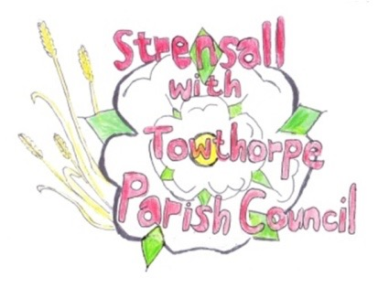
STRENSALL WITH TOWTHORPE PARISH COUNCIL
The Village Hall, Northfields, Strensall, York YO325XW
e-mail: strensalltowthorpePC@outlook.com phone: 01904 491569

MINUTES OF A PLANNING COMMITTEE MEETING HELD ON TUESDAY 28th JUNE 2022 AT 6.30PM

Councillors Present: Andrew Bolton Chris Chambers John Chapman Tony Fisher Ray Maher
In Attendance: Fiona Hill - Parish Clerk
Public Present: 0
- a) To receive apologies for absence given in advance of the meeting: None
b) To consider the approval of reasons given for absence: N/A

- To receive any declarations of interest under the Parish Council Code of Conduct or
Members register of interests:
Cllr Bolton – has a general interest in all planning applications along Lords Moor Lane (22/00464/FUL)
Cllr Fisher – had been lobbied by the owner of Lambshill (22/01032/FUL)
Cllrs Chambers/Fisher – are members of F.I.D.B. (22/01032/FUL)

- To approve the minutes of the Planning Committee meeting of 14th June 2022: Resolved/Approved (Unanimous)

- To discuss any ongoing issues and information received: a) 22/00464/FUL - Raising of ridge height to facilitate loft conversion and partial rendering of external elevations, erection of gates to front access @ Caerglow, Lords Moor Lane Resolved – No Objections, The amended drawing have satisfied the Parish Councils original objection (Unanimous) b) 22/01032/FUL - Change of use of agricultural land to the siting of 118 storage containers (use class B8) – retrospective @ BHE Self Storage Facility, Lambshill, Towthorpe Moor Lane Resolved – Objection, The Parish Council notes the revised drawings, which do nothing to justify this inappropriate development in the green belt. (3 votes in favour of the resolution and 2 abstentions)

- To consider and respond to consultations from City of York Council to the following
planning applications: 22/01159/FUL – Proposed single storey rear extension and two storey side extension @ 17 Riverside Walk
Resolved – No Objection, but the Parish Council is concerned about the loss storage space
due to removal of existing

- To note planning decisions received: a) 22/00775/FUL - Erection of single storey summer house/office to rear of garden and erection
of storage shed to front garden (part retrospective) @ 37 York Road - Approved
- 22/00824/ADV - Display of 1no. externally illuminated fascia sign, 1no. externally illuminated projecting sign, and 3no. window vinyls @ Tesco, 40 The Village - Refused
- 22/00936/TCA - Crown reduce and lift 1no. Scots Pine tree in a Conservation Area @ 4 West End - Consented

22/36 To confirm date of next meeting as Tuesday 12th July 2022 @ 6.30 p.m. Resolved/Approved (Unanimous)

